Supplementary Information
This section provides an in-depth discussion of our supply chain mapping methodology, a comprehensive list of supply chain components, and detail on key model outputs.
Supply Chain Mapping Methodology
Our measurement methodology consists of two key steps: mapping the supply chain for each technology and identifying the appropriate HS6 code that corresponds to each component or piece of process equipment. We began with the identification of two types of supply chain inputs: products in the supply chain themselves, and process equipment used to refine materials. First, we identified the supply chain of each technology, including the final product, components, subcomponents, processed materials, and raw materials. Second, we identified the process chain consisting of the steps involved in manufacturing the final technology, and the main components of each piece of process equipment. This involved identifying the equipment for each manufacturing step, sourced from pre-existing manufacturing process diagrams for each technology and its subcomponents created by academic, government, and industry sources.
Peer-reviewed papers, cited below, were prioritized for identifying supply chain components and materials, as well as manufacturing steps in the technology manufacturing process chain and corresponding equipment. When peer-reviewed sources were unavailable, industry and government sources were used. We created composite itemizations of supply chain components, materials, and process chains from this combination of sources. Note that in most supply chains, processed material equipment was not mapped to avoid the overinclusion of components used in common base materials production. Certain exceptions were made if the processed material was highly specific to the technological supply chain in question, a determination made based on readings of the academic literature around a technology. No equipment involved in the production of raw materials was mapped, to avoid the inclusion of common mining and processing equipment.
We then mapped each identified component, subcomponent, processed material and piece of equipment onto 6-digit HS codes. Among better researched technologies, papers and government sources both mapped parts of the supply chain, process chain, and included corresponding HS code identification. If sources provided differing HS codes, academic sources were held as the definitive source, then direct communications with industry sources or industry websites, then government sources. Where information was sparse, especially in the process chain, we contacted producers of equipment and turned to their website to determine the relevant HS code for each piece of process equipment.
Where existing HS codes were unavailable from an academic, government, or industry source, we use the WITTS HS code repository identify the HS code that best approximates the component, piece of equipment, or material identified in academic literature or industry technical diagrams. Raw materials were primarily mapped to HS codes if they were identified as an input to a technology.
Below, Table SI.1 lays out our sources for each component and piece of process equipment utilized in a solar panel. We utilize the most up-to-date version of the 2022 HS code dictionary but harmonize our analysis to the HS codes present in 2002. This allows us to use our data for identifying trends in more differentiated clean technologies (e.g. multiple types of solar cells, differentiated in 2022 while also taking a historical view of aggregated HS codes).

Supply Chain Components by Technology
The following section details the list of components in the supply chains of each of our ten technologies, and provides a categorization of their upstream, midstream, or downstream position in the supply chain.
Table SI.1. Solar Supply Chain
Product Code | Product Description
901820 | Medical, surgical instruments and appliances: ultra-violet or infra-red ray apparatus
854149 | Electrical apparatus: photosensitive semiconductor devices, diodes other than light emitting diodes and photovoltaic cells whether or not assembled in modules or made up into panels
854143 | Electrical apparatus: photosensitive semiconductor devices, photovoltaic cells assembled in modules or made up into panels
854142 | Electrical apparatus: photosensitive semiconductor devices, photovoltaic cells not assembled in modules or made up into panels
854140 | Electrical apparatus: photosensitive, including photovoltaic cells, whether or not assembled in modules or made up into panels, light-emitting diodes (LED)
854129 | Electrical apparatus: transistors, (other than photosensitive), with a dissipation rate of 1W or more
851519 | Brazing or soldering machines and apparatus: other than soldering irons and guns, whether or not capable of cutting
851440 | Heating equipment: for the heat treatment of materials by induction or dielectric loss, industrial or laboratory, other than furnaces and ovens
851432 | Furnaces and ovens: electric, for industrial or laboratory use, other than those functioning by induction, dielectric loss or resistance heated, plasma and vacuum arc furnaces
850180 | Electric generators: (excluding generating sets), photovoltaic AC generators (alternators)
850172 | Electric generators: photovoltaic DC generators, of an output exceeding 50W
850171 | Electric generators: photovoltaic DC generators, of an output not exceeding 50W
848690 | Machines and apparatus of heading 8486: parts and accessories
848640 | Machines and apparatus of a kind used solely or principally for the manufacture or repair of masks and reticles, assembling semiconductor devices or electronic integrated circuits, or for lifting, handling, loading or unloading items of heading 8486
848620 | Machines and apparatus of a kind used solely or principally for the manufacture of semiconductor devices or of electronic integrated circuits
848610 | Machines and apparatus of a kind used solely or principally for the manufacture of semiconductor boules or wafers
847989 | Machines and mechanical appliances: having individual functions, n.e.c. or included in this chapter
845630 | Machine-tools: for working any material by removal of material, operated by electro-discharge processes
841989 | Machinery, plant and laboratory equipment: for treating materials by change of temperature, other than for making hot drinks or cooking or heating food
830249 | Mountings, fittings and similar articles: suitable for other than buildings or furniture, of base metal
811292 | Gallium, germanium, indium, niobium (columbium) and vanadium: articles thereof, unwrought, including waste and scrap, powders
761090 | Aluminium: structures (excluding prefabricated buildings of heading no. 9406) and parts of structures, n.e.c. in heading no. 7610, plates, rods, profiles, tubes and the like
760310 | Aluminium: powders of non-lamellar structure
760120 | Aluminium: unwrought, alloys
710692 | Metals: silver, semi-manufactured
700719 | Glass: safety glass, toughened (tempered), (not of a size and shape suitable for incorporation in vehicles, aircraft, spacecraft or vessels)
700529 | Glass: float glass and surface ground or polished glass, in sheets, non-wired, (other than coloured throughout the mass (body tinted), opacified, flashed or merely surface ground)
700510 | Glass: float glass and surface ground or polished glass, in sheets, non-wired, having an absorbent reflecting or non-reflecting layer
392062 | Plastics: plates, sheets, film, foil and strip (not self-adhesive), of poly(ethylene terephthalate), non-cellular and not reinforced, laminated, supported or similarly combined with other materials
392030 | Plastics: of polymers of styrene, plates, sheets, film, foil and strip (not self-adhesive), non-cellular and not reinforced, laminated, supported or similarly combined with other materials
392010 | Plastics: plates, sheets, film, foil and strip (not self-adhesive), of polymers of ethylene, non-cellular and not reinforced, laminated, supported or similarly combined with other materials
390761 | Poly(ethylene terephthalate): in primary forms, having a viscosity of 78ml/g or higher
390730 | Epoxide resins: in primary forms
390469 | Halogenated olefin polymers: fluoro-polymers (other than polytetrafluoroethylene), in primary forms
390130 | Ethylene polymers: in primary forms, ethylene-vinyl acetate copolymers
381800 | Chemical elements: doped for use in electronics, in the form of discs, wafers or similar forms: chemical compounds doped for use in electronics
350610 | Glues or adhesives: prepared, products suitable for use as glues or adhesives, put up for retail sale as glues or adhesives, not exceeding a net weight of 1kg
320890 | Paints and varnishes: based on polymers n.e.c. in heading no. 3208, dispersed or dissolved in a non-aqueous medium
281820 | Aluminium oxide: other than artificial corundum
281410 | Ammonia: anhydrous
280490 | Selenium
280469 | Silicon: containing by weight less than 99.99% of silicon
280461 | Silicon: containing by weight not less than 99.99% of silicon
280450 | Boron: tellurium
261610 | Silver ores and concentrates
260900 | Tin ores and concentrates
260600 | Aluminium ores and concentrates
260400 | Nickel ores and concentrates
260300 | Copper ores and concentrates
251910 | Magnesium carbonate (magnesite): natural
250510 | Sands: natural, silica and quartz sands, whether or not coloured

Table SI.2. Wind Supply Chain
Product Code | Product Description
903190 | Instruments, appliances and machines: parts and accessories for those measuring or checking devices of heading no. 9031
902920 | Meters: speed indicators and tachometers: stroboscopes
902830 | Meters: electricity supply or production meters, including calibrating meters thereof
902680 | Instruments and apparatus: for measuring or checking variables of liquids or gases (excluding pressure or the flow and level of liquids and those of heading no. 9014, 9015, 9028 and 9032)
902580 | Hydrometers and similar floating instruments, barometers, hygrometers, psychrometers, thermometers, pyrometers: recording or not, any combination of these instruments (excluding thermometers and barometers not combined with other instruments)
870840 | Vehicle parts: gear boxes and parts thereof
870830 | Vehicle parts: brakes, servo-brakes and parts thereof
854460 | Insulated electric conductors: for a voltage exceeding 1000 volts
854411 | Insulated electric conductors: winding wire, of copper
854390 | Electrical machines and apparatus: parts of the electrical goods of heading no. 8543
854370 | Electrical machines and apparatus: having individual functions, not specified or included elsewhere in this chapter, n.e.c. in heading no. 8543
853670 | Connectors for optical fibres, optical fibre bundles or cables
853650 | Electrical apparatus: switches n.e.c. in heading no. 8536, for a voltage not exceeding 1000 volts
851580 | Welding machines and apparatus: n.e.c. in heading no. 8515, whether or not capable of cutting
851521 | Welding machines and apparatus: for resistance welding of metal, fully or partly automatic, whether or not capable of cutting
850519 | Magnets: permanent magnets and articles intended to become permanent magnets after magnetisation, other than of metal
850511 | Magnets: permanent magnets and articles intended to become permanent magnets after magnetisation, of metal
850431 | Electrical transformers: n.e.c. in item no. 8504.2, having a power handling capacity not exceeding 1kVA
850300 | Electric motors and generators: parts suitable for use solely or principally with the machines of heading no. 8501 or 8502
850231 | Electric generating sets: wind-powered, (excluding those with spark-ignition or compression-ignition internal combustion piston engines)
850164 | Electric generators: AC generators, (alternators), other than photovoltaic generators, of an output exceeding 750kVA
850163 | Electric generators: AC generators, (alternators), other than photovoltaic generators, of an output exceeding 375kVA but not exceeding 750kVA
850162 | Electric generators: AC generators, (alternators), other than photovoltaic generators, of an output exceeding 75kVA but not exceeding 375kVA
850161 | Generators: AC generators, (alternators), other than photovoltaic generators, of an output not exceeding 75kVA
848360 | Clutches and shaft couplings (including universal joints)
848340 | Gears and gearing: (not toothed wheels, chain sprockets and other transmission elements presented separately): ball or roller screws: gear boxes and other speed changers, including torque converters
848330 | Bearing housings, not incorporating ball or roller bearings and plain shaft bearings
848310 | Transmission shafts (including cam shafts and crank shafts) and cranks
848299 | Bearings: parts, (other than balls, needles and rollers)
848280 | Bearings: n.e.c. in heading no. 8482, including combined ball/roller
848250 | Bearings: cylindrical roller bearings, including cage and roller assemblies n.e.c. in heading no. 8482
848240 | Bearings: needle roller bearings, including cage and needle roller assemblies
848230 | Bearings: spherical roller bearings
848220 | Bearings: tapered roller bearings, including cone and tapered roller assemblies
848210 | Ball bearings
847989 | Machines and mechanical appliances: having individual functions, n.e.c. or included in this chapter
847740 | Machinery: vacuum moulding machines and other thermoforming machines, for working rubber or plastics or for the manufacture of products from these materials
846224 | Machine-tools: bending, folding, straightening or flattening machines (including presses), for working metal, numerically controlled panel benders
846221 | Machine-tools: bending, folding, straightening or flattening machines (including presses), numerically controlled, for working metal
846039 | Machine-tools: sharpening (tool or cutter grinding) machines, other than numerically controlled
845430 | Casting machines: of a kind used in metallurgy or in metal foundries
844630 | Weaving machines (looms): for weaving fabrics of a width exceeding 30cm, shuttleless type
842890 | Lifting, handling, loading or unloading machinery: n.e.c. in heading no. 8425, 8426, 8427 or 8428
842691 | Cranes and derricks: designed for mounting on road vehicles
842430 | Mechanical appliances: steam or sand blasting machines and similar jet projecting machines
842420 | Spray guns and similar appliances
841989 | Machinery, plant and laboratory equipment: for treating materials by change of temperature, other than for making hot drinks or cooking or heating food
841290 | Engines: parts, for engines and motors of heading no. 8412
841229 | Engines: hydraulic power engines and motors, other than linear acting (cylinders)
841221 | Engines: hydraulic power engines and motors, linear acting (cylinders)
820900 | Tools: plates, sticks, tips and the like for tools, unmounted, of sintered metal carbides or cermets
790111 | Zinc: unwrought, (not alloyed), containing by weight 99.99% or more of zinc
760429 | Aluminium: alloys, bars, rods and profiles, other than hollow
760110 | Aluminium: unwrought, (not alloyed)
740110 | Copper: copper mattes
732690 | Iron or steel: articles n.e.c. in heading 7326
732611 | Iron or steel: grinding balls and similar articles for mills, forged or stamped, but not further worked
732399 | Iron or steel: table, kitchen and other household articles and parts thereof, of iron or steel n.e.c. in heading no. 7323
730820 | Iron or steel: structures and parts thereof, towers and lattice masts
730799 | Iron or steel: tube or pipe fittings, n.e.c. in item no. 7307.9, other than stainless steel
730791 | Iron or steel: tube or pipe fittings, flanges, other than stainless steel
730640 | Steel, stainless: tubes, pipes and hollow profiles, welded, of circular cross-section, n.e.c. in chapter 73
730110 | Iron or steel: sheet piling, whether or not drilled, punched or made from assembled elements
681599 | Stone articles and articles of other mineral substances: n.e.c. or included in heading no. 6815
681511 | Stone or other mineral substances not elsewhere specified or included: carbon fibres for non-electrical uses
401699 | Rubber: vulcanised (other than hard rubber), articles n.e.c. in heading no. 4016, of non-cellular rubber
401693 | Rubber: vulcanised (other than hard rubber), gaskets, washers and other seals, of non-cellular rubber
392690 | Plastics: other articles n.e.c. in chapter 39
392590 | Plastics: builders' ware, n.e.c. or included in heading no. 3925
391732 | Plastics: tubes, pipes and hoses thereof, other than those of item no. 3917.31, not reinforced or otherwise combined with other materials, without fittings
391729 | Plastics: tubes, pipes and hoses thereof, rigid, of plastics n.e.c. in heading no. 3917
391723 | Plastics: tubes, pipes and hoses thereof, rigid, of polymers of vinyl chloride
391722 | Plastics: tubes, pipes and hoses thereof, rigid, of polymers of propylene
391721 | Plastics: tubes, pipes and hoses thereof, rigid, of polymers of ethylene
390791 | Polyesters: n.e.c. in heading no. 3907, unsaturated, in primary forms
390210 | Propylene, other olefin polymers: polypropylene in primary forms
390110 | Ethylene polymers: in primary forms, polyethylene having a specific gravity of less than 0.94
350691 | Adhesives: prepared, based on polymers of heading 3901 to 3913 or on rubber
320890 | Paints and varnishes: based on polymers n.e.c. in heading no. 3208, dispersed or dissolved in a non-aqueous medium
290949 | Ether-alcohols and their halogenated, sulphonated, nitrated or nitrosated derivatives: n.e.c. in item no. 2909.4
281820 | Aluminium oxide: other than artificial corundum
280530 | Earth-metals, rare: scandium and yttrium, whether or not intermixed or interalloyed
261400 | Titanium ores and concentrates
261390 | Molybdenum ores and concentrates: other than roasted
261310 | Molybdenum ores and concentrates: roasted
261000 | Chromium ores and concentrates
260800 | Zinc ores and concentrates
260600 | Aluminium ores and concentrates
260400 | Nickel ores and concentrates
260300 | Copper ores and concentrates
260200 | Manganese ores and concentrates, including ferruginous manganese ores and concentrates with a manganese content of 20% or more, calculated on the dry weight

Table SI.3. Battery Supply Chain
Product Code | Product Description
903190 | Instruments, appliances and machines: parts and accessories for those measuring or checking devices of heading no. 9031
903180 | Instruments, appliances and machines: for measuring or checking n.e.c. in chapter 90
903149 | Optical instruments and appliances: for measuring or checking, n.e.c. in chapter 90
903089 | Instruments and apparatus: n.e.c. in heading no. 9030, without a recording device
903039 | Instruments and apparatus: for measuring or checking voltage, current, resistance or power, with a recording device (excluding multimeters)
903033 | Instruments and apparatus: for measuring or checking voltage, current, resistance or power, without a recording device (excluding multimeters)
903031 | Multimeters: for measuring or checking voltage, current, resistance or power (other than those for measuring or checking semiconductor wafer or devices), without a recording device
902780 | Instruments and apparatus: for physical or chemical analysis, for measuring or checking viscosity, porosity, expansion, surface tension or quantities of heat, sound or light, n.e.c. in heading no. 9027
851580 | Welding machines and apparatus: n.e.c. in heading no. 8515, whether or not capable of cutting
850790 | Electric accumulators: parts n.e.c. in heading no. 8507
850780 | Electric accumulators: other than lead-acid, nickel-cadmium, nickel-metal hydride and lithium-ion, including separators, whether or not rectangular (including square)
850760 | Electric accumulators: lithium-ion, including separators, whether or not rectangular (including square)
847989 | Machines and mechanical appliances: having individual functions, n.e.c. or included in this chapter
847982 | Machines: for mixing, kneading, crushing, grinding, screening, sifting, homogenising, emulsifying or stirring
847981 | Machines and mechanical appliances: for treating metal, including electric wire coil-winders
847720 | Machinery: extruders, for working rubber or plastics or for the manufacture of products from these materials
847710 | Machinery: injection-moulding machines, for working rubber or plastics or for the manufacture of products from these materials
846223 | Machine-tools: bending, folding, straightening or flattening machines (including presses), for working metal, numerically controlled press brakes
846150 | Machine-tools: sawing or cutting-off machines, working by removing metal, sintered metal carbides or cermets
845521 | Metal-rolling mills: hot or combination hot and cold rolling mills
842489 | Mechanical appliances: for projecting, dispersing or spraying liquids or powders, for other than agricultural or horticultural use, whether or not hand-operated
842240 | Machinery: for packing or wrapping
842119 | Centrifuges: n.e.c. in heading no. 8421, including centrifugal dryers (but not clothes-dryers)
842010 | Machines: calendering or other rolling machines, for other than metal or glass
841939 | Dryers: for products n.e.c. in heading no. 8419, not used for domestic purposes
811100 | Manganese: articles thereof, including waste and scrap
810520 | Cobalt: mattes and other intermediate products of cobalt metallurgy, unwrought cobalt, powders
761699 | Aluminium: articles n.e.c. in heading 7616
760720 | Aluminium: foil, backed with paper, paperboard, plastics or similar backing materials, of a thickness (excluding any backing) not exceeding 0.2mm
750120 | Nickel: oxide sinters and other intermediate products of nickel metallurgy
750110 | Nickel: nickel mattes
392020 | Plastics: of polymers of propylene, plates, sheets, film, foil and strip (not self-adhesive), non-cellular and not reinforced, laminated, supported or similarly combined with other materials
392010 | Plastics: plates, sheets, film, foil and strip (not self-adhesive), of polymers of ethylene, non-cellular and not reinforced, laminated, supported or similarly combined with other materials
391910 | Plastics: plates, sheets, film, foil, tape, strip, other flat shapes thereof, self-adhesive, in rolls of a width not exceeding 20cm
391000 | Silicones: in primary forms
390760 | Poly(ethylene terephthalate): in primary forms
390210 | Propylene, other olefin polymers: polypropylene in primary forms
382499 | Chemical products, mixtures and preparations: n.e.c. heading 3824
382490 | Chemical products, preparations and residual products of the chemical or allied industries, n.e.c. or included in heading no. 3824
380190 | Graphite or other carbon based preparations: in the form of pastes, blocks, plates or other semi-manufactures
380110 | Graphite: artificial
290122 | Acyclic hydrocarbons: unsaturated, propene (propylene)
290121 | Acyclic hydrocarbons: unsaturated, ethylene
285390 | Phosphides, chemically defined or not, not ferrophosphorus: other inorganic compounds n.e.c. (including distilled, conductivity water and water of like purity): liquid air, rare gases removed or not: compressed air: amalgams, not precious metal amalgams
284290 | Salts: of inorganic acids or peroxoacids, other than double or complex silicates, including aluminosilicates, whether or not chemically, excluding azides
283699 | Carbonates: n.e.c. in heading no. 2836 and other than lithium or strontium
283691 | Carbonates: lithium carbonate
283529 | Phosphates: (other than of mono- or disodium, other than of potassium or of calcium hydrogenorthophosphate (dicalcium phosphate) and excluding other phosphates of calcium), whether or not chemically defined
283329 | Sulphates: n.e.c. in item no. 2833.2
283324 | Sulphates: of nickel
282690 | Fluorides: fluorosilicates, fluoroaluminates and other complex fluorine salts, n.e.c. in heading no. 2826
282619 | Fluorides: other than of aluminium
282540 | Nickel oxides and hydroxides
282520 | Lithium oxide and hydroxide
282510 | Hydrazine and hydroxylamine and their inorganic salts
282200 | Cobalt oxides and hydroxides: commercial cobalt oxides
282090 | Manganese oxides: excluding manganese dioxide
282010 | Manganese dioxide
281820 | Aluminium oxide: other than artificial corundum
280519 | Alkali or alkali-earth metals: other than sodium and calcium
271312 | Petroleum coke: calcined, obtained from bituminous minerals
270400 | Coke and semi-coke: of coal, lignite or peat, whether or not agglomerated: retort carbon
260600 | Aluminium ores and concentrates
260500 | Cobalt ores and concentrates
260400 | Nickel ores and concentrates
260300 | Copper ores and concentrates
260200 | Manganese ores and concentrates, including ferruginous manganese ores and concentrates with a manganese content of 20% or more, calculated on the dry weight
260120 | Iron pyrites: roasted
260112 | Iron ores and concentrates: agglomerated (excluding roasted iron pyrites)
260111 | Iron ores and concentrates: non-agglomerated
251020 | Natural calcium phosphates, natural aluminium calcium phosphates and phosphatic chalk: ground
250410 | Graphite: natural, in powder or in flakes

Table SI.4. Biofuel Supply Chain
Product Code | Product Description
842139 | Machinery: for filtering or purifying gases, other than intake air filters, catalytic converters or particulate filters for internal combustion engines
842121 | Machinery: for filtering or purifying water
842119 | Centrifuges: n.e.c. in heading no. 8421, including centrifugal dryers (but not clothes-dryers)
841990 | Machinery, plant and laboratory equipment: parts of equipment for treating materials by a process involving a change of temperature
841989 | Machinery, plant and laboratory equipment: for treating materials by change of temperature, other than for making hot drinks or cooking or heating food
841950 | Heat exchange units: not used for domestic purposes
841940 | Distilling or rectifying plant: not used for domestic purposes
841939 | Dryers: for products n.e.c. in heading no. 8419, not used for domestic purposes
841430 | Compressors: of a kind used in refrigerating equipment
841410 | Pumps: vacuum
841381 | Pumps and liquid elevators: n.e.c. in heading no. 8413
840619 | Turbines: steam and other vapour turbines, for other than marine propulsion
840211 | Boilers: watertube boilers with a steam production exceeding 45t per hour
810210 | Molybdenum: articles thereof, including waste and scrap, powders
810110 | Tungsten (wolfram): articles thereof, including waste and scrap, powders
711021 | Metals: palladium, unwrought or in powder form
711011 | Metals: platinum, unwrought or in powder form
440130 | Wood: sawdust, waste and scrap, whether or not agglomerated in logs, briquettes, pellets or similar forms
440122 | Wood: for fuel, in chips or particles, non-coniferous, whether or not agglomerated
440121 | Wood: for fuel, in chips or particles, coniferous, whether or not agglomerated
440110 | Wood: for fuel, in logs, billets, twigs, faggots or similar forms, whether or not agglomerated
381519 | Catalysts, supported: reaction initiators, reaction accelerators and catalytic preparations, with an active substance other than nickel or precious metals or their compounds, n.e.c. or included
381512 | Catalysts, supported: reaction initiators, reaction accelerators and catalytic preparations, with precious metal or precious metal compounds as the active substance, n.e.c. or included
381511 | Catalysts, supported: reaction initiators, reaction accelerators and catalytic preparations, with nickel or nickel compounds as the active substance, n.e.c. or included
293290 | Heterocyclic compounds: n.e.s. in heading no. 2932
290514 | Alcohols: saturated monohydric, butanols excluding item no. 2905.13
284210 | Salts of inorganic acids or peroxoacids, double or complex silicates, including aluminosilicates, whether or not chemically defined, excluding azides
283324 | Sulphates: of nickel
282560 | Germanium oxides and zirconium dioxide
282300 | Titanium oxides
282200 | Cobalt oxides and hydroxides: commercial cobalt oxides
281830 | Aluminium hydroxide
281820 | Aluminium oxide: other than artificial corundum
281511 | Sodium hydroxide (caustic soda): solid
261510 | Zirconium ores and concentrates
261400 | Titanium ores and concentrates
261310 | Molybdenum ores and concentrates: roasted
261100 | Tungsten ores and concentrates
260500 | Cobalt ores and concentrates
260400 | Nickel ores and concentrates
220720 | Ethyl alcohol and other spirits: denatured, of any strength
151610 | Animal fats and oils and their fractions: partly or wholly hydrogenated, inter-esterified, re-esterified or elaidinised, whether or not refined, but not further prepared
151529 | Vegetable oils: maize (corn) oil and its fractions, other than crude, whether or not refined, but not chemically modified
151521 | Vegetable oils: maize (corn) oil and its fractions, crude, not chemically modified
151490 | Vegetable oils: rape, colza or mustard oil and their fractions, other than crude, whether or not refined, but not chemically modified
151329 | Vegetable oils: palm kernel or babassu oil and their fractions, other than crude, whether or not refined, but not chemically modified
151000 | Vegetable oils: oils and their fractions n.e.c. in chapter 15, obtained solely from olives, whether or not refined, but not chemically modified, including blends of these oils or fractions with oils or fractions of heading no. 1509
150790 | Vegetable oils: soya-bean oil and its fractions, other than crude, whether or not refined, but not chemically modified
121300 | Cereal straw and husks: unprepared, whether or not chopped, ground, pressed or in the form of pellets
121292 | Locust beans (carob): fit for human consumption, fresh, chilled, frozen or dried, whether or not ground

Table SI.5. Geothermal Supply Chain
Product Code | Product Description
851580 | Welding machines and apparatus: n.e.c. in heading no. 8515, whether or not capable of cutting
851539 | Welding machines and apparatus: for arc (including plasma arc) welding of metals, other than fully or partly automatic, whether or not capable of cutting
851531 | Welding machines and apparatus: for arc (including plasma arc) welding of metals, fully or partly automatic, whether or not capable of cutting
851490 | Furnaces, ovens and heating equipment: parts of the industrial or laboratory equipment of heading no. 8514
851430 | Furnaces and ovens: electric, for industrial or laboratory use, other than those functioning by induction, dielectric loss or resistance heated
850239 | Electric generating sets: (excluding those with spark-ignition or compression-ignition internal combustion piston engines), other than wind powered
848210 | Ball bearings
847982 | Machines: for mixing, kneading, crushing, grinding, screening, sifting, homogenising, emulsifying or stirring
846630 | Parts & accessories suited for use solely/principally with machines of headings 8456-8465: dividing heads and other special attachments for machines
846210 | Machine-tools: forging or die-stamping machines (including presses) and hammers, for working metal
846090 | Machine-tools: for deburring, grinding, polishing or otherwise finishing metal, sintered metal carbides or cermets by means of grinding stones, abrasives or polishing products, n.e.c. in heading no. 8460
846021 | Machine-tools: grinding machines (other than flat-surface), in which positioning in any one axis can be set up to at least an accuracy of 0.01mm, numerically controlled
845961 | Machine-tools: for milling by removing metal, (not knee-type), numerically controlled
845931 | Machine-tools: for boring-milling by removing metal, numerically controlled
845921 | Machine-tools: for drilling by removing metal, numerically controlled
845891 | Lathes: for removing metal, numerically controlled, other than horizontal lathes
845710 | Machining centres: for working metal
845640 | Machine tools: for working any material by removal of material: operated by plasma arc processes:
845610 | Machine-tools: for working any material by removal of material, operated by laser or other light or photon beam processes
845521 | Metal-rolling mills: hot or combination hot and cold rolling mills
845510 | Metal-rolling mills: tube mills
845430 | Casting machines: of a kind used in metallurgy or in metal foundries
843143 | Boring or sinking machinery: parts for boring or sinking machinery of subheading 8430.41 or 8430.49
843049 | Boring and sinking machinery: not self-propelled
843041 | Boring or sinking machinery: self-propelled, n.e.c. in heading no. 8430
842641 | Cranes: self-propelled derricks and cranes, on tyres, n.e.c. in heading no. 8426
842139 | Machinery: for filtering or purifying gases, other than intake air filters, catalytic converters or particulate filters for internal combustion engines
841989 | Machinery, plant and laboratory equipment: for treating materials by change of temperature, other than for making hot drinks or cooking or heating food
841950 | Heat exchange units: not used for domestic purposes
841710 | Furnaces and ovens: non-electric, for the roasting, melting or other heat-treatment of ores, pyrites or of metals, for industrial or laboratory use
841391 | Pumps: parts thereof
840690 | Turbines: parts of steam and other vapour turbines
840682 | Turbines: steam and other vapour turbines, (for other than marine propulsion), of an output not exceeding 40MW
840681 | Turbines: steam and other vapour turbines, (for other than marine propulsion), of an output exceeding 40MW
840420 | Boilers: condensers, for steam or other vapour power units
820750 | Tools, interchangeable: (for machine or hand tools, whether or not power-operated), tools for drilling (other than rock)
820719 | Tools, interchangeable: rock drilling or earth boring tools, with working part (other than of cermets), whether or not power operated, including parts
732620 | Iron or steel: wire articles
731815 | Iron or steel: threaded screws and bolts n.e.c. in item no. 7318.1, whether or not with their nuts or washers
730791 | Iron or steel: tube or pipe fittings, flanges, other than stainless steel
730721 | Steel, stainless: tube or pipe fittings, flanges, of stainless steel
730420 | Iron or steel (other than cast iron): seamless casing, tubing and drill pipe, of a kind used in drilling for oil or gas
722490 | Steel, alloy: semi-finished products
722410 | Steel, alloy: ingots and other primary forms
720610 | Iron or non-alloy steel: ingots (excluding iron of heading no. 7203)
720291 | Ferro-alloys: ferro-titanium and ferro-silico-titanium
720270 | Ferro-alloys: ferro-molybdenum
720260 | Ferro-alloys: ferro-nickel
720249 | Ferro-alloys: ferro-chromium, containing by weight 4% or less of carbon
720230 | Ferro-alloys: ferro-silico-manganese
710510 | Stones: precious and semi-precious, dust and powder, of diamonds
710229 | Diamonds: industrial, (other than unworked or simply sawn, cleaved or bruted), but not mounted or set
401693 | Rubber: vulcanised (other than hard rubber), gaskets, washers and other seals, of non-cellular rubber
400259 | Rubber: synthetic, acrylonitrile-butadiene rubber (NBR), (other than latex), in primary forms or in plates, sheets or strip
400249 | Rubber: synthetic, chloroprene (chlorobutadiene) rubber (CR), (other than latex), in primary forms or in plates, sheets or strip
391000 | Silicones: in primary forms
390461 | Halogenated olefin polymers: fluoro-polymers, polytetrafluoroethylene, in primary forms
340399 | Lubricating preparations: other than for the treatment of textile and similar materials, not containing petroleum oils or oils obtained from bituminous minerals
283620 | Carbonates: disodium carbonate
271114 | Petroleum gases and other gaseous hydrocarbons: liquefied, ethylene, propylene, butylene and butadiene
271000 | Petroleum oils and oils from bituminous minerals, not crude: preparations n.e.c. containing by weight 70% or more of petroleum oils or oils from bituminous minerals: these being the basic constituents of the preparations: waste oils
270900 | Oils: petroleum oils and oils obtained from bituminous minerals, crude
261400 | Titanium ores and concentrates
261390 | Molybdenum ores and concentrates: other than roasted
261000 | Chromium ores and concentrates
260600 | Aluminium ores and concentrates
260400 | Nickel ores and concentrates
260300 | Copper ores and concentrates
260200 | Manganese ores and concentrates, including ferruginous manganese ores and concentrates with a manganese content of 20% or more, calculated on the dry weight
260120 | Iron pyrites: roasted
260112 | Iron ores and concentrates: agglomerated (excluding roasted iron pyrites)
260111 | Iron ores and concentrates: non-agglomerated
252520 | Mica: powder
252330 | Cement: aluminous (ciment fondu), whether or not coloured or in the form of clinkers
252100 | Limestone flux: limestone and other calcareous stone, of a kind used for the manufacture of lime or cement
250810 | Clays (excluding expanded clays of heading no. 6806): bentonite, whether or not calcined

Table SI.6. Nuclear Supply Chain
Product Code | Product Description
845430 | Casting machines: of a kind used in metallurgy or in metal foundries
841989 | Machinery, plant and laboratory equipment: for treating materials by change of temperature, other than for making hot drinks or cooking or heating food
841940 | Distilling or rectifying plant: not used for domestic purposes
841780 | Furnaces and ovens: including incinerators, non-electric, for industrial or laboratory use, n.e.c. in heading no. 8417
840690 | Turbines: parts of steam and other vapour turbines
840681 | Turbines: steam and other vapour turbines, (for other than marine propulsion), of an output exceeding 40MW
840420 | Boilers: condensers, for steam or other vapour power units
840140 | Nuclear reactors: parts thereof
840130 | Fuel elements (cartridges): non-irradiated
840120 | Machinery and apparatus: for isotopic separation, and parts thereof
840110 | Nuclear reactors
810990 | Zirconium: other than unwrought, n.e.c. in heading no. 8109
722790 | Steel, alloy: bars and rods, hot-rolled, in irregularly wound coils, n.e.c. in heading no. 7227
721922 | Steel, stainless: flat-rolled, width 600mm or more, hot-rolled, (not in coils), of a thickness of 4.75mm or more but not exceeding 10mm
721921 | Steel, stainless: flat-rolled, width 600mm or more, hot-rolled, (not in coils), of a thickness exceeding 10mm
720270 | Ferro-alloys: ferro-molybdenum
720260 | Ferro-alloys: ferro-nickel
681099 | Cement, concrete or artificial stone: articles (other than prefabricated structural components for building or civil engineering), whether or not reinforced, n.e.c. in heading no. 6810
380110 | Graphite: artificial
284510 | Heavy water (deuterium oxide)
284450 | Spent (irradiated) fuel elements (cartridges) of nuclear reactors
284430 | Uranium: depleted in U235, thorium, their compounds, alloys, dispersions (including cermets), ceramic products and mixtures containing uranium depleted in U235, thorium: compounds of these products
284420 | Uranium: enriched in U235, plutonium, their compounds, alloys dispersions (including cermets), ceramic products and mixtures containing uranium enriched in U235, plutonium or compounds of these products
284410 | Uranium: natural uranium and its compounds, alloys, dispersions (including cermets), ceramic products and mixtures containing natural uranium or natural uranium compounds
282611 | Fluorides: of ammonium or of sodium
282520 | Lithium oxide and hydroxide
281290 | Halides and halide oxides of non-metals: excluding chloride
281000 | Oxides of boron: boric acids
261510 | Zirconium ores and concentrates
261390 | Molybdenum ores and concentrates: other than roasted
261210 | Uranium ores and concentrates
261000 | Chromium ores and concentrates
260700 | Lead ores and concentrates
260400 | Nickel ores and concentrates
260300 | Copper ores and concentrates
260200 | Manganese ores and concentrates, including ferruginous manganese ores and concentrates with a manganese content of 20% or more, calculated on the dry weight
260120 | Iron pyrites: roasted
260112 | Iron ores and concentrates: agglomerated (excluding roasted iron pyrites)
260111 | Iron ores and concentrates: non-agglomerated
252890 | Borates: natural, and concentrates thereof, n.e.c. in heading no. 2528, excluding borates separated from natural brine: natural boric acid containing not more than 85% of H3Bo3 calculated on the dry weight
250410 | Graphite: natural, in powder or in flakes

Table SI.7. Electrolyzers Supply Chain
Product Code | Product Description
901380 | Optical devices, appliances and instruments: n.e.c. in heading no. 9013
854380 | Electrical machines and apparatus: having individual functions, n.e.s. in heading no. 8543
854370 | Electrical machines and apparatus: having individual functions, not specified or included elsewhere in this chapter, n.e.c. in heading no. 8543
854330 | Electrical machines and apparatus: for electroplating, electrolysis or electrophoresis
851430 | Furnaces and ovens: electric, for industrial or laboratory use, other than those functioning by induction, dielectric loss or resistance heated
847982 | Machines: for mixing, kneading, crushing, grinding, screening, sifting, homogenising, emulsifying or stirring
847981 | Machines and mechanical appliances: for treating metal, including electric wire coil-winders
846261 | Machine-tools: cold metal working presses, hydraulic presses
846241 | Machine-tools: punching or notching machines (including presses), including combined punching and shearing machines, numerically controlled, for working metal
846150 | Machine-tools: sawing or cutting-off machines, working by removing metal, sintered metal carbides or cermets
845611 | Machine-tools: for working any material by removal of material: operated by laser
844319 | Printing machinery: used for printing by means of plates, cylinders and other printing components of heading 84.42, n.e.c. in item no. 8443.1
842489 | Mechanical appliances: for projecting, dispersing or spraying liquids or powders, for other than agricultural or horticultural use, whether or not hand-operated
842139 | Machinery: for filtering or purifying gases, other than intake air filters, catalytic converters or particulate filters for internal combustion engines
842121 | Machinery: for filtering or purifying water
841990 | Machinery, plant and laboratory equipment: parts of equipment for treating materials by a process involving a change of temperature
841950 | Heat exchange units: not used for domestic purposes
841939 | Dryers: for products n.e.c. in heading no. 8419, not used for domestic purposes
841899 | Refrigerating or freezing equipment: parts thereof, other than furniture
841869 | Refrigerating or freezing equipment: n.e.c. in heading no. 8418
841861 | Heat pumps: other than air conditioning machines of heading no. 8415
841490 | Pumps and compressors: parts, of air or vacuum pumps, air or other gas compressors and fans, ventilating or recycling hoods incorporating a fan
841370 | Pumps: centrifugal, n.e.c. in heading no. 8413, for liquids
820730 | Tools, interchangeable: (for machine or hand tools, whether or not power-operated), tools for pressing, stamping or punching
810210 | Molybdenum: articles thereof, including waste and scrap, powders
810110 | Tungsten (wolfram): articles thereof, including waste and scrap, powders
711041 | Metals: iridium, osmium, ruthenium, unwrought or in powder form
711021 | Metals: palladium, unwrought or in powder form
711011 | Metals: platinum, unwrought or in powder form
400270 | Rubber: synthetic, ethylene-propylene-non-conjugated diene rubber (EPDM), in primary forms or in plates, sheets or strip
391400 | Ion-exchangers: based on polymers of heading no. 3901 to 3913, in primary forms
391000 | Silicones: in primary forms
390290 | Propylene, other olefin polymers: n.e.c. in heading no. 3902, in primary forms
390230 | Propylene, other olefin polymers: propylene copolymers in primary forms
390190 | Ethylene polymers: in primary forms, n.e.c. in heading no. 3901
390130 | Ethylene polymers: in primary forms, ethylene-vinyl acetate copolymers
381512 | Catalysts, supported: reaction initiators, reaction accelerators and catalytic preparations, with precious metal or precious metal compounds as the active substance, n.e.c. or included
381511 | Catalysts, supported: reaction initiators, reaction accelerators and catalytic preparations, with nickel or nickel compounds as the active substance, n.e.c. or included
284330 | Gold compounds
283699 | Carbonates: n.e.c. in heading no. 2836 and other than lithium or strontium
283329 | Sulphates: n.e.c. in item no. 2833.2
283324 | Sulphates: of nickel
282300 | Titanium oxides
282200 | Cobalt oxides and hydroxides: commercial cobalt oxides
261400 | Titanium ores and concentrates
261390 | Molybdenum ores and concentrates: other than roasted
261310 | Molybdenum ores and concentrates: roasted
261100 | Tungsten ores and concentrates
260500 | Cobalt ores and concentrates
260400 | Nickel ores and concentrates

Table SI.8. Heat Pump Supply Chain
Product Code | Product Description
841581 | Air conditioning machines: containing a motor driven fan, other than window or wall types, incorporating a refrigerating unit and a valve for reversal of the cooling/heat cycle (reversible heat pumps)
841861 | Heat pumps: other than air conditioning machines of heading no. 8415
841430 | Compressors: of a kind used in refrigerating equipment
841590 | Air conditioning machines: with motor driven fan and elements for temperature control, parts thereof
841410 | Pumps: vacuum
841381 | Pumps and liquid elevators: n.e.c. in heading no. 8413
841490 | Pumps and compressors: parts, of air or vacuum pumps, air or other gas compressors and fans, ventilating or recycling hoods incorporating a fan
840290 | Boilers: parts of steam or other vapour generating boilers
841899 | Refrigerating or freezing equipment: parts thereof, other than furniture
846241 | Machine-tools: punching or notching machines (including presses), including combined punching and shearing machines, numerically controlled, for working metal
846229 | Machine-tools: bending, folding, straightening or flattening machines (including press brakes), for working metal, numerically controlled n.e.c. in item 84.62.2
851521 | Welding machines and apparatus: for resistance welding of metal, fully or partly automatic, whether or not capable of cutting
846150 | Machine-tools: sawing or cutting-off machines, working by removing metal, sintered metal carbides or cermets
820720 | Tools, interchangeable: (for machine or hand tools, whether or not power-operated), dies for drawing or extruding metal
841582 | Air conditioning machines: containing a motor driven fan, other than window or wall types, incorporating a refrigerating unit
252921 | Fluorspar: containing by weight 97% or less of calcium fluoride
853400 | Circuits: printed
741110 | Copper: tubes and pipes, of refined copper
760820 | Aluminium: tubes and pipes, alloys
740313 | Copper: refined, unwrought, billets
740110 | Copper: copper mattes
760120 | Aluminium: unwrought, alloys
281820 | Aluminium oxide: other than artificial corundum
260300 | Copper ores and concentrates
260600 | Aluminium ores and concentrates
261390 | Molybdenum ores and concentrates: other than roasted
260400 | Nickel ores and concentrates
251910 | Magnesium carbonate (magnesite): natural

Table SI.9. Permanent Magnet Supply Chain
Product Code | Product Description
854330 | Electrical machines and apparatus: for electroplating, electrolysis or electrophoresis
851440 | Heating equipment: for the heat treatment of materials by induction or dielectric loss, industrial or laboratory, other than furnaces and ovens
850519 | Magnets: permanent magnets and articles intended to become permanent magnets after magnetisation, other than of metal
850511 | Magnets: permanent magnets and articles intended to become permanent magnets after magnetisation, of metal
847989 | Machines and mechanical appliances: having individual functions, n.e.c. or included in this chapter
847982 | Machines: for mixing, kneading, crushing, grinding, screening, sifting, homogenising, emulsifying or stirring
845630 | Machine-tools: for working any material by removal of material, operated by electro-discharge processes
820720 | Tools, interchangeable: (for machine or hand tools, whether or not power-operated), dies for drawing or extruding metal
760120 | Aluminium: unwrought, alloys
720293 | Ferro-alloys: ferro-niobium
680421 | Millstones, grindstones, grinding wheels and the like: of agglomerated synthetic or natural diamond
284690 | Compounds, inorganic or organic (excluding cerium), of rare-earth metals, of yttrium, scandium or of mixtures of these metals
283324 | Sulphates: of nickel
280530 | Earth-metals, rare: scandium and yttrium, whether or not intermixed or interalloyed
261590 | Niobium, tantalum, vanadium ores and concentrates
260600 | Aluminium ores and concentrates
260400 | Nickel ores and concentrates
260300 | Copper ores and concentrates
260120 | Iron pyrites: roasted

Table SI.10. Transmission Supply Chain
Product Code | Product Description
850431 | Electrical transformers: n.e.c. in item no. 8504.2, having a power handling capacity not exceeding 1kVA
850432 | Transformers: n.e.c. in item no. 8504.2, having a power handling capacity exceeding 1kVA but not exceeding 16kVA
850433 | Transformers: n.e.c. in item no. 8504.2, having a power handling capacity exceeding 16kVA but not exceeding 500kVA
850434 | Transformers: n.e.c. in item no. 8504.2, having a power handling capacity exceeding 500kVA
850490 | Electrical transformers, static converters and inductors: parts thereof
846150 | Machine-tools: sawing or cutting-off machines, working by removing metal, sintered metal carbides or cermets
846241 | Machine-tools: punching or notching machines (including presses), including combined punching and shearing machines, numerically controlled, for working metal
846249 | Machine-tools: punching, notching or nibbling machines (excluding presses) for flat products including combined punching and shearing machines, other than numerically controlled, for working metal
842890 | Lifting, handling, loading or unloading machinery: n.e.c. in heading no. 8425, 8426, 8427 or 8428
847981 | Machines and mechanical appliances: for treating metal, including electric wire coil-winders
841939 | Dryers: for products n.e.c. in heading no. 8419, not used for domestic purposes
847989 | Machines and mechanical appliances: having individual functions, n.e.c. or included in this chapter
842230 | Machinery: for filling, closing, sealing, capsuling or labelling bottles, cans, bags or other containers, machinery for aerating beverages
854690 | Electrical insulators: other than of glass and ceramics
722611 | Steel, alloy: flat-rolled, width less than 600mm, of silicon-electrical steel, grain-oriented
845530 | Metal-rolling mills: rolls thereof
845522 | Metal-rolling mills: cold
841710 | Furnaces and ovens: non-electric, for the roasting, melting or other heat-treatment of ores, pyrites or of metals, for industrial or laboratory use
760521 | Aluminium: alloys, wire, maximum cross-sectional dimension exceeding 7mm
740811 | Copper: wire, of refined copper, of which the maximum cross-sectional dimension exceeds 6mm
281290 | Halides and halide oxides of non-metals: excluding chloride
740110 | Copper: copper mattes
281820 | Aluminium oxide: other than artificial corundum
260111 | Iron ores and concentrates: non-agglomerated
260112 | Iron ores and concentrates: agglomerated (excluding roasted iron pyrites)
260120 | Iron pyrites: roasted
260300 | Copper ores and concentrates
260600 | Aluminium ores and concentrates
270900 | Oils: petroleum oils and oils obtained from bituminous minerals, crude

Cross validation diagnostics
The following section provides cross validation results for each random forest model. We use 5-fold cross validation (CV) and test accuracy on a left-out test set. We use tree depths of 5, 10, and 15, and 50, 100, and 150 estimators to test the CV accuracy of each model, leveraging multiple metrics of classification accuracy. We select the specification that maximizes CV accuracy without running into issues of memorization.
Figure SI.11. Solar Cross Validation
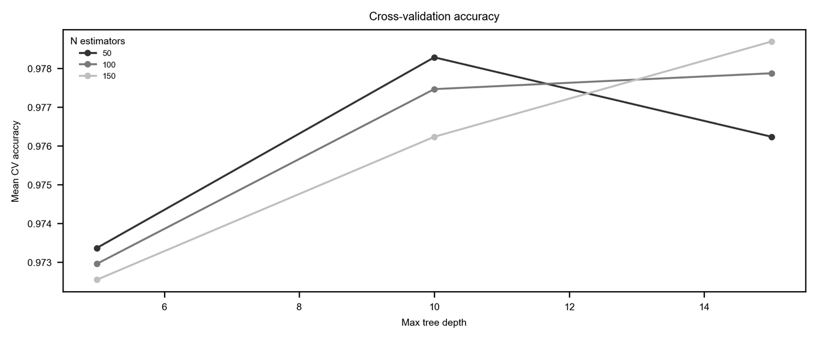
Figure SI.12. Wind Cross Validation
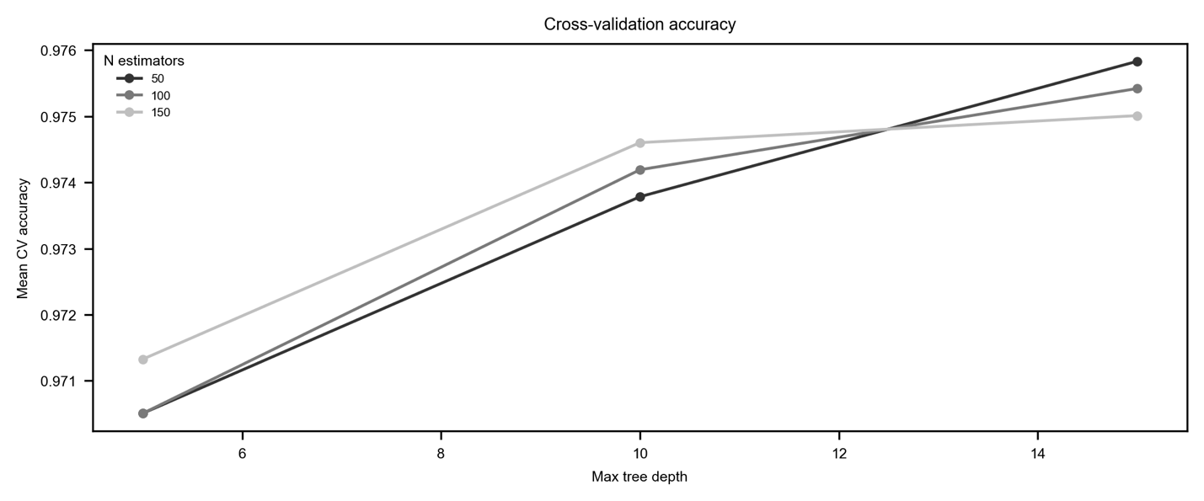
Figure SI.13. Battery Cross Validation
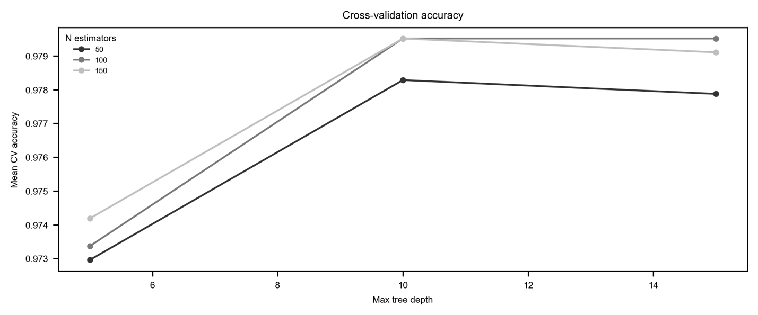
Figure SI.14. Biofuel Cross Validation
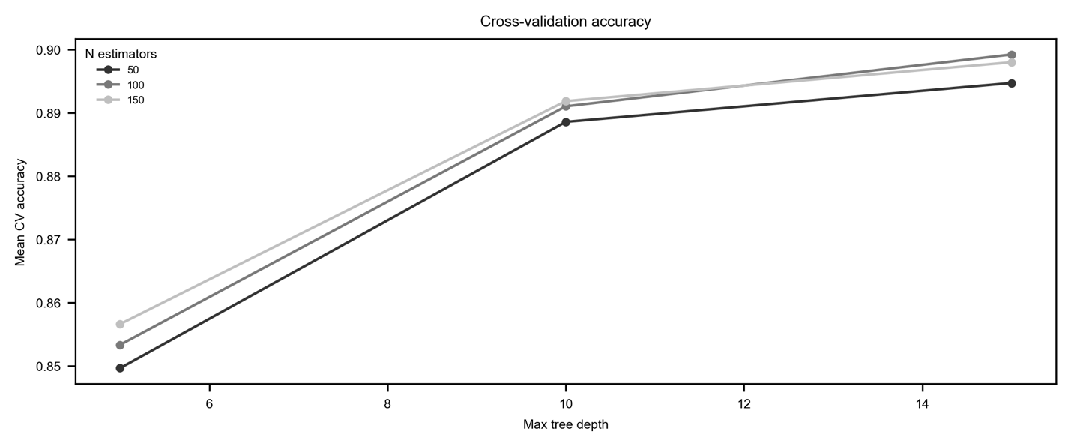
Figure SI.15. Geothermal Cross Validation
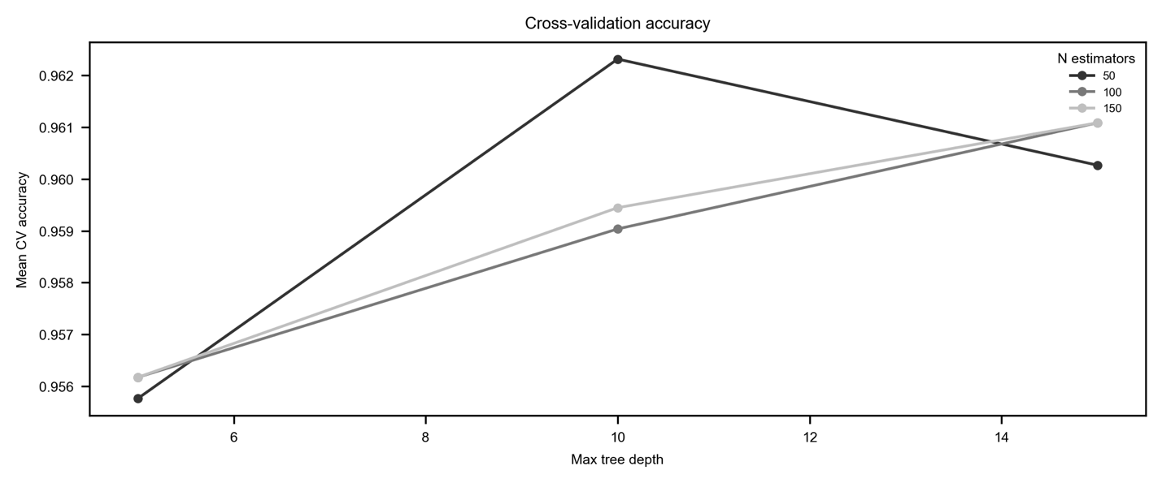
Figure SI.16. Nuclear Cross Validation
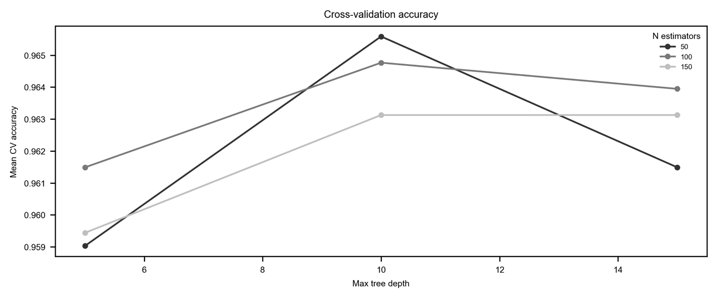
Figure SI.17. Electrolyzers Cross Validation
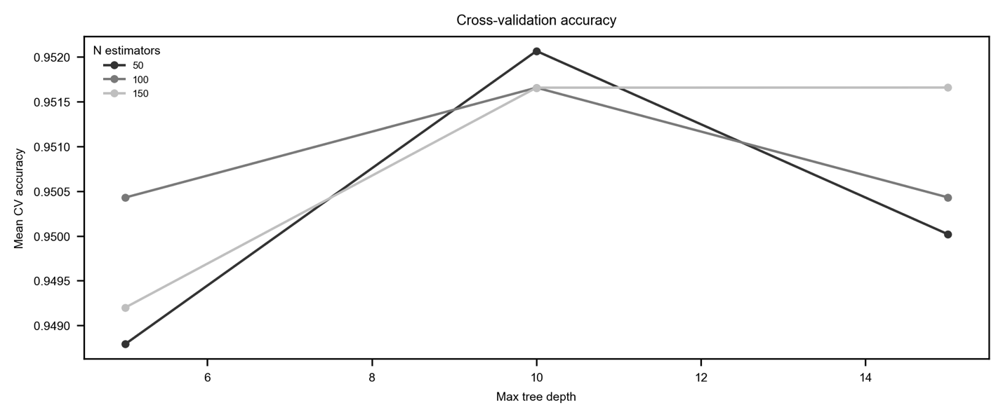
Figure SI.18. Heat Pump Cross Validation
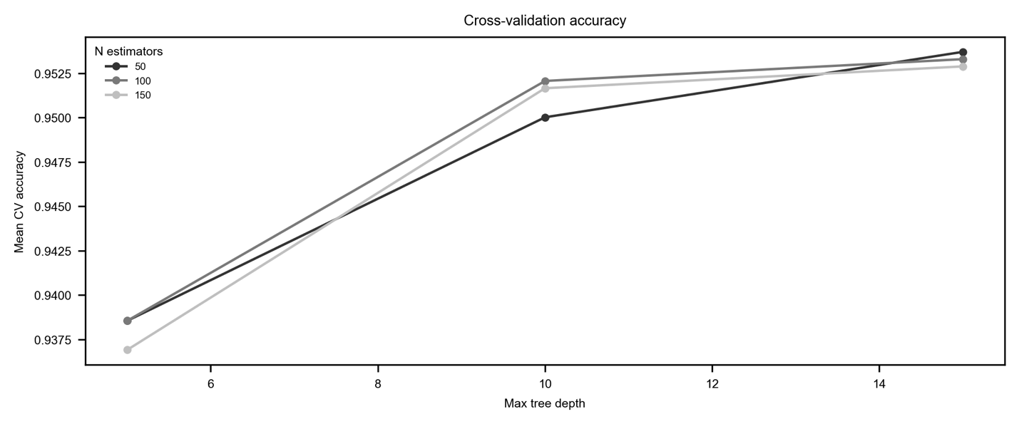
Figure SI.19. Permanent Magnets Cross Validation
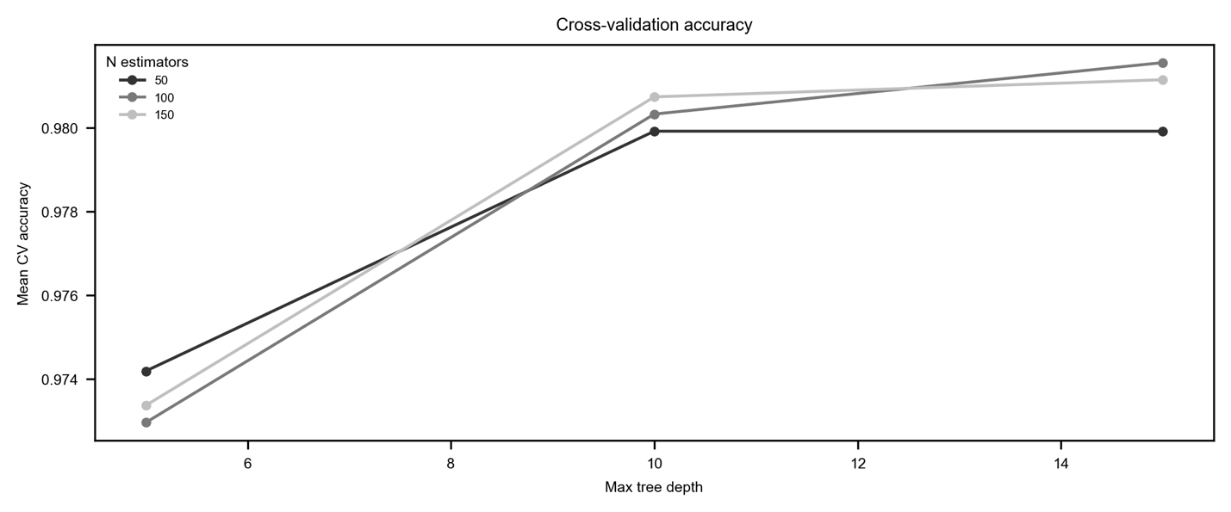
Figure SI.20. Transmission Cross Validation
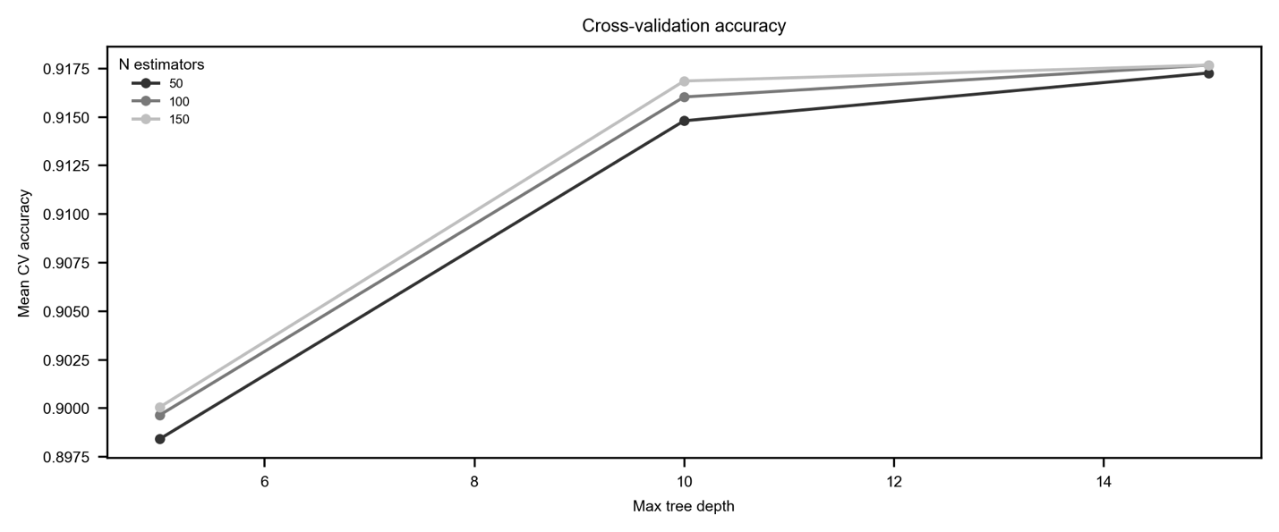
Features by mean absolute z-score of SHAP value (> 0.5) by technology
Below, we list the HS codes and country-level independent variables that have a mean absolute z-score above our cutoff of 0.5 which suggests a moderate-to-high impact on the model predictions. We report features by each technology, and include the HS codes, their descriptions, and category of technology.
Table SI.21. Solar features by mean absolute z-score
HS Code | Description | Category | Mean absolute z-score
830249 | Mountings, fittings and similar articles; suitable for other than buildings or furniture, of base metal | Metals | 0.715290588
392350 | Plastics; stoppers, lids, caps and other closures, for the conveyance or packing of goods | Chemicals | 0.659440095
851440 | Heating equipment; for the heat treatment of materials by induction or dielectric loss, industrial or laboratory, other than furnaces and ovens | Electronics | 0.626772306
851430 | Furnaces and ovens; industrial or laboratory, other than those functioning by induction, dielectric loss or resistance heated | Electronics | 0.623957749
 | Industry % GDP | Non-HS | 0.604842659
730890 | Iron or steel; structures and parts thereof, n.e.s. in heading no. 7308 | Metals | 0.604073196
940390 | Furniture; parts | Machinery | 0.602998191
732690 | Iron or steel; articles n.e.s. in heading no. 7326 | Metals | 0.601553918
392069 | Plastics; plates, sheets, film, foil and strip, of polyesters n.e.s. in heading no. 3920, non-cellular and not reinforced, laminated, supported or similarly combined with other materials | Chemicals | 0.593027456
 | Trade % GDP | Non-HS | 0.592948072
854389 | Electrical machines and apparatus; n.e.s. in heading no. 8543, (other than proximity cards or tags), having individual functions n.e.s. in chapter 85 | Electronics | 0.578359649
700719 | Glass; safety glass, toughened (tempered), (not of a size and shape suitable for incorporation in vehicles, aircraft, spacecraft or vessels) | Industrial Materials | 0.566543511
848041 | Moulds; for metal or metal carbides, injection or compression types | Machinery | 0.565481457
320910 | Paints and varnishes; based on acrylic or vinyl polymers, dispersed or dissolved in an aqueous medium | Chemicals | 0.565010539
847790 | Machinery; parts of those for working rubber or plastics | Machinery | 0.560462817
400270 | Rubber; synthetic, ethylene-propylene-non-conjugated diene rubber (EPDM), in primary forms or in plates, sheets or strip | Chemicals | 0.55712462
280461 | Silicon; containing by weight not less than 99.99% of silicon | Chemicals | 0.54892292
320990 | Paints and varnishes; (based on polymers other than acrylic or vinyl), dispersed or dissolved in an aqueous medium | Chemicals | 0.548305093
320820 | Paints and varnishes; based on acrylic or vinyl polymers, dispersed or dissolved in a non-aqueous medium | Chemicals | 0.543997916
320890 | Paints and varnishes; based on polymers n.e.s. in heading no. 3208, dispersed or dissolved in a non-aqueous medium | Chemicals | 0.543177822
 | GDP | Non-HS | 0.543163236
390730 | Epoxide resins; in primary forms | Chemicals | 0.542555852
760421 | Aluminium; alloys, hollow profiles | Metals | 0.541923155
851519 | Brazing or soldering machines and apparatus; other than soldering irons and guns, whether or not capable of cutting | Electronics | 0.53264397
391000 | Silicones; in primary forms | Chemicals | 0.529292983
390469 | Halogenated olefin polymers; fluoro-polymers (other than polytetrafluoroethylene), in primary forms | Chemicals | 0.524661117
847990 | Machines and mechanical appliances; parts, of those having individual functions | Machinery | 0.524498482
761010 | Aluminium; structures (excluding prefabricated buildings of heading no. 9406) and parts of structures, doors, windows and their frames and thresholds for doors | Metals | 0.52287353
 | Manufacturing % GDP | Non-HS | 0.521764733
392030 | Plastics; of polymers of styrene, plates, sheets, film, foil and strip, non-cellular and not reinforced, laminated, supported or similarly combined with other materials | Chemicals | 0.52119055
761090 | Aluminium; structures (excluding prefabricated buildings of heading no. 9406) and parts of structures, n.e.s. in heading no. 7610, plates, rods, profiles, tubes and the like | Metals | 0.52074065
281820 | Aluminium oxide; other than artificial corundum | Chemicals | 0.520595088
760429 | Aluminium; alloys, bars, rods and profiles, other than hollow | Metals | 0.519805152
 | Tariff Implementation | Non-HS | 0.519111482
850131 | Electric motors and generators; DC, of an output not exceeding 750W | Electronics | 0.516762882
281410 | Ammonia; anhydrous | Chemicals | 0.515460358
321490 | Mastics; n.e.s. in heading no. 3214 | Chemicals | 0.513360915
250510 | Sands; natural, silica and quartz sands, whether or not coloured | Industrial Materials | 0.51056715
392010 | Plastics; plates, sheets, film, foil and strip, of polymers of ethylene, non-cellular and not reinforced, laminated, supported or similarly combined with other materials | Chemicals | 0.510554223
392062 | Plastics; plates, sheets, film, foil and strip, of poly(ethylene terephthalate), non-cellular and not reinforced, laminated, supported or similarly combined with other materials | Chemicals | 0.507496145
390740 | Polycarbonates; in primary forms | Chemicals | 0.504188694
370130 | Photographic plates and film; in the flat, sensitised, unexposed, with any side exceeding 225mm, of any materials other than paper, paperboard or textiles | Chemicals | 0.503073061

Table SI.22. Wind features by mean absolute z-score
HS Code | Description | Category | Mean absolute z-score
732690 | Iron or steel; articles n.e.s. in heading no. 7326 | Metals | 0.69001176
401693 | Rubber; vulcanised (other than hard rubber), gaskets, washers and other seals, of non-cellular rubber | Chemicals | 0.665057
870810 | Vehicles; bumpers and parts thereof, for the vehicles of heading no. 8701 to 8705 | Machinery | 0.64808389
 | GDP | Non-HS | 0.64780776
842890 | Lifting machinery; handling, loading or unloading machinery n.e.s. in heading no. 8428 | Machinery | 0.63512302
730640 | Steel, stainless; tubes and pipes, welded, of circular cross-section | Metals | 0.62659438
321490 | Mastics; n.e.s. in heading no. 3214 | Chemicals | 0.62585638
846221 | Machine-tools; bending, folding, straightening or flattening machines (including presses), numerically controlled, for working metal | Machinery | 0.62256009
260300 | Copper ores and concentrates | Metals | 0.61088462
870850 | Vehicles; parts, drive-axles with differential, whether or not provided with other transmission components | Machinery | 0.60748419
850164 | Electric generators; AC generators, (alternators), of an output exceeding 750kVA | Electronics | 0.6026569
401699 | Rubber; vulcanised (other than hard rubber), articles n.e.s. in heading no. 4016, of non-cellular rubber | Chemicals | 0.59994805
260800 | Zinc ores and concentrates | Metals | 0.59576495
841989 | Machinery, plant and laboratory equipment; for treating materials by change of temperature, other than for making hot drinks or cooking or heating food | Machinery | 0.5938265
730799 | Iron or steel; tube or pipe fittings, n.e.s. in item no. 7307.9, other than stainless steel | Metals | 0.59148227
260700 | Lead ores and concentrates | Metals | 0.58940333
260200 | Manganese ores and concentrates, including ferruginous manganese ores and concentrates with a manganese content of 20% or more, calculated on the dry weight | Metals | 0.58217395
391723 | Plastics; tubes, pipes and hoses thereof, rigid, of polymers of vinyl chloride | Chemicals | 0.58142438
761699 | Aluminium; n.e.s. in heading no. 7616 | Metals | 0.58081504
730890 | Iron or steel; structures and parts thereof, n.e.s. in heading no. 7308 | Metals | 0.57960859
261000 | Chromium ores and concentrates | Metals | 0.57331309
845430 | Casting machines; of a kind used in metallurgy or in metal foundries | Machinery | 0.57114079
 | Industry % GDP | Non-HS | 0.56875005
854411 | Insulated electric conductors; winding wire, of copper | Electronics | 0.56474075
842420 | Spray guns and similar appliances | Machinery | 0.56435206
850163 | Electric generators; AC generators, (alternators), of an output exceeding 375kVA but not exceeding 750kVA | Electronics | 0.55903551
732399 | Iron or steel; table, kitchen and other household articles and parts thereof, of iron or steel n.e.s. in heading no. 7323 | Metals | 0.55593057
870894 | Vehicles; parts, steering wheels, columns and boxes | Machinery | 0.55541207
850511 | Magnets; permanent magnets and articles intended to become permanent magnets after magnetisation, of metal | Electronics | 0.55490903
850519 | Magnets; permanent magnets and articles intended to become permanent magnets after magnetisation, other than of metal | Electronics | 0.55385156
840999 | Engines; parts for internal combustion piston engines (excluding spark-ignition) | Machinery | 0.55188002
 | Manufacturing % GDP | Non-HS | 0.55027515
260600 | Aluminium ores and concentrates | Metals | 0.54802463
848299 | Bearings; parts, (other than balls, needles and rollers) | Machinery | 0.54774891
870839 | Vehicles; brakes, servo brakes and parts, not mounted brake linings | Machinery | 0.54399238
820900 | Tools; plates, sticks, tips and the like for tools, unmounted, of sintered metal carbides or cermets | Metals | 0.54350756
903180 | Instruments, appliances and machines; for measuring or checking n.e.s. in chapter 90 | Machinery | 0.53887325
320810 | Paints and varnishes; based on polyesters, dispersed or dissolved in a non-aqueous medium | Chemicals | 0.53821126
850162 | Electric generators; AC generators, (alternators), of an output exceeding 75kVA but not exceeding 375kVA | Electronics | 0.53396801
 | Trade | Non-HS | 0.5338306
320820 | Paints and varnishes; based on acrylic or vinyl polymers, dispersed or dissolved in a non-aqueous medium | Chemicals | 0.52568015
846231 | Machine-tools; shearing machines (including presses), (other than combined punching and shearing machines), numerically controlled, for working metal | Machinery | 0.52501836
848220 | Bearings; tapered roller bearings, including cone and tapered roller assemblies | Machinery | 0.52217813
848291 | Bearings; parts, balls, needles and rollers | Machinery | 0.52023517
441520 | Wood; pallets, box pallets and other load boards; pallet collars | Industrial Materials | 0.5131568
841221 | Engines; hydraulic power engines and motors, linear acting (cylinders) | Machinery | 0.50935689
850161 | Generators; AC generators, (alternators), of an output not exceeding 75kVA | Electronics | 0.50884444
392690 | Plastics; other articles n.e.s. in chapter 39 | Chemicals | 0.50860024
840820 | Engines; compression-ignition internal combustion piston engines (diesel or semi-diesel engines), of a kind used for the propulsion of vehicles of chapter 87 | Machinery | 0.5046585
851521 | Welding machines and apparatus; for resistance welding of metal, fully or partly automatic, whether or not capable of cutting | Electronics | 0.50454999
940390 | Furniture; parts | Machinery | 0.50342881
850300 | Electric motors and generators; parts suitable for use solely or principally with the machines of heading no. 8501 or 8502 | Electronics | 0.50167329

Table SI.23. Battery features by mean absolute z-score
HS Code | Description | Category | Mean absolute z-score
846231 | Machine-tools; shearing machines (including presses), (other than combined punching and shearing machines), numerically controlled, for working metal | Machinery | 0.69599058
391190 | Polysulphides, polysulphones and similar products of chemical synthesis n.e.s. in chapter 39; in primary forms | Chemicals | 0.67484357
382490 | Chemical products, preparations and residual products of the chemical or allied industries, n.e.s. or included in heading no. 3824 | Chemicals | 0.66253734
903039 | Instruments and apparatus; for measuring or checking voltage, current, resistance or power, without a recording device (excluding multimeters) | Machinery | 0.6561503
846221 | Machine-tools; bending, folding, straightening or flattening machines (including presses), numerically controlled, for working metal | Machinery | 0.64197594
847990 | Machines and mechanical appliances; parts, of those having individual functions | Machinery | 0.64047919
761699 | Aluminium; n.e.s. in heading no. 7616 | Metals | 0.61952362
903190 | Instruments, appliances and machines; parts and accessories for those measuring or checking devices of heading no. 9031 | Machinery | 0.61405946
282540 | Nickel oxides and hydroxides | Chemicals | 0.60581447
851580 | Welding machines and apparatus; n.e.s. in heading no. 8515, whether or not capable of cutting | Electronics | 0.60114896
280519 | Alkali or alkali-earth metals; other than sodium and calcium | Chemicals | 0.59992889
370130 | Photographic plates and film; in the flat, sensitised, unexposed, with any side exceeding 225mm, of any materials other than paper, paperboard or textiles | Chemicals | 0.59654522
260400 | Nickel ores and concentrates | Metals | 0.59081057
847989 | Machines and mechanical appliances; n.e.s. in item no. 8479.8, having individual functions | Machinery | 0.58598668
283324 | Sulphates; of nickel | Chemicals | 0.58253019
903089 | Instruments and apparatus; for measuring or detecting alpha, beta, gamma, x-ray, cosmic or other ionising radiations, without a recording device | Machinery | 0.57901663
902790 | Microtomes and parts and accessories thereof | Machinery | 0.57485832
903180 | Instruments, appliances and machines; for measuring or checking n.e.s. in chapter 90 | Machinery | 0.5698803
 | Tariffs affected | Non-HS | 0.56930253
392091 | Plastics; plates, sheets, film, foil and strip, of poly(vinyl butyral), non-cellular and not reinforced, laminated, supported or similarly combined with other materials | Chemicals | 0.56781928
282200 | Cobalt oxides and hydroxides; commercial cobalt oxides | Chemicals | 0.56658441
392010 | Plastics; plates, sheets, film, foil and strip, of polymers of ethylene, non-cellular and not reinforced, laminated, supported or similarly combined with other materials | Chemicals | 0.55630347
903149 | Optical instruments and appliances; for measuring or checking, n.e.s. in chapter 90 | Machinery | 0.55409134
850790 | Electric accumulators; parts n.e.s. in heading no. 8507 | Electronics | 0.55311528
 | Industry % GDP | Non-HS | 0.54476865
391000 | Silicones; in primary forms | Chemicals | 0.54256396
 | GDP | Non-HS | 0.53912987
842489 | Mechanical appliances; for projecting, dispersing or spraying liquids or powders, for other than agricultural or horticultural use, whether or not hand-operated | Machinery | 0.53789591
260600 | Aluminium ores and concentrates | Metals | 0.53568354
260111 | Iron ores and concentrates; non-agglomerated | Metals | 0.53443493
390469 | Halogenated olefin polymers; fluoro-polymers (other than polytetrafluoroethylene), in primary forms | Chemicals | 0.52911733
 | Manufacturing % GDP | Non-HS | 0.52552678
847981 | Machines and mechanical appliances; for treating metal, including electric wire coil-winders | Machinery | 0.5250675
390210 | Propylene, other olefin polymers; polypropylene in primary forms | Chemicals | 0.51968086
282090 | Manganese oxides; excluding manganese dioxide | Chemicals | 0.51854211
390710 | Polyacetals; in primary forms | Chemicals | 0.50959556
284800 | Phosphides; whether or not chemically defined, (excluding ferrophosphorus) | Chemicals | 0.5030011
291613 | Acids; unsaturated acyclic monocarboxylic acids; methacrylic acid and its salts | Chemicals | 0.50278802

Table SI.24. Biofuel features by mean absolute z-score
HS Code | Description | Category | Mean absolute z-score
381590 | Reaction initiators, reaction accelerators and catalytic preparations, unsupported, n.e.s. or included | Chemicals | 0.83855851
844190 | Machinery; parts of machinery for making up paper pulp, paper or paperboard, including cutting machines of all kinds | Machinery | 0.80575214
841381 | Pumps and liquid elevators; n.e.s. in heading no. 8413 | Machinery | 0.79488616
121299 | Vegetable products (including unroasted chicory roots, chicorium intybus sativum variety); n.e.s. in chapter 12, fresh, chilled, frozen or dried, ground or unground, primarily for human consumption | Other | 0.79278107
940390 | Furniture; parts | Machinery | 0.79116
 | Industry % GDP | Non-HS | 0.78604247
441520 | Wood; pallets, box pallets and other load boards; pallet collars | Industrial Materials | 0.77151343
870892 | Vehicles; parts, silencers and exhaust pipes | Machinery | 0.76885393
842139 | Machinery; for filtering or purifying gases, other than intake air filters for internal combustion engines | Machinery | 0.76506488
283650 | Carbonates; calcium carbonate | Chemicals | 0.76442809
842121 | Machinery; for filtering or purifying water | Machinery | 0.75937783
 | GDP | Non-HS | 0.75181291
841410 | Pumps; vacuum | Machinery | 0.74911575
441810 | Wood; windows, French-windows and their frames | Industrial Materials | 0.74895344
291814 | Acids; carboxylic acids, (with alcohol function but without other oxygen function), citric acid | Chemicals | 0.74216809
150990 | Vegetable oils; olive oil and its fractions, other than virgin, whether or not refined, but not chemically modified | Other | 0.74055884
281122 | Silicon dioxide | Chemicals | 0.73748018
842119 | Centrifuges; n.e.s. in heading no. 8421, including centrifugal dryers (but not clothes-dryers) | Machinery | 0.72949478
380210 | Carbon; activated | Chemicals | 0.72898622
281121 | Carbon dioxide | Chemicals | 0.72420484
441890 | Wood; builders' joinery and carpentry of wood n.e.s. in heading no. 4418 | Industrial Materials | 0.72168257
151329 | Vegetable oils; palm kernel or babassu oil and their fractions, other than crude, whether or not refined, but not chemically modified | Other | 0.71758334
284210 | Salts; double or complex silicates, including aluminosilicates, whether or not chemically defined | Chemicals | 0.71475713
440110 | Wood; for fuel, in logs, billets, twigs, faggots or similar forms | Industrial Materials | 0.70695328
840420 | Boilers; condensers, for steam or other vapour power units | Machinery | 0.70537444
841430 | Compressors; of a kind used in refrigerating equipment | Machinery | 0.70443211
282570 | Molybdenum oxides and hydroxides | Chemicals | 0.6966532
 | Manufacturing % GDP | Non-HS | 0.69584363
841989 | Machinery, plant and laboratory equipment; for treating materials by change of temperature, other than for making hot drinks or cooking or heating food | Machinery | 0.69377748
690290 | Refractory bricks, blocks, tiles and similar refractory ceramic constructional goods; n.e.s. in item no. 6902.1 or 6902.2 | Industrial Materials | 0.6882646
151529 | Vegetable oils; maize (corn) oil and its fractions, other than crude, whether or not refined, but not chemically modified | Other | 0.68697647
841939 | Dryers; for products n.e.s. in heading no. 8419, not used for domestic purposes | Machinery | 0.68615553
440130 | Wood; sawdust, waste and scrap, whether or not agglomerated in logs, briquettes, pellets or similar forms | Industrial Materials | 0.68524544
381519 | Catalysts, supported; reaction initiators, reaction accelerators and catalytic preparations, with an active substance other than nickel or precious metals or their compounds, n.e.s. or included | Chemicals | 0.6755803
282300 | Titanium oxides | Chemicals | 0.67357228
440320 | Wood; coniferous, in the rough, whether or not stripped of bark or sapwood, or roughly squared, untreated | Industrial Materials | 0.67254384
841950 | Heat exchange units; not used for domestic purposes | Machinery | 0.67252677
220720 | Ethyl alcohol and other spirits; denatured, of any strength | Other | 0.67068253
 | FDI | Non-HS | 0.66389127
690220 | Refractory bricks, blocks, tiles and similar refractory ceramic constructional goods; containing by weight more than 50% of alumina (Al2o3), of silica (SiO2) or of a mixture or compound of these | Industrial Materials | 0.6605884
151000 | Vegetable oils; oils and their fractions n.e.s. in chapter 15, obtained solely from olives, whether or not refined, but not chemically modified, including blends of these oils or fractions with oils or fractions of heading no. 1509 | Other | 0.65664669
681510 | Stone articles and other mineral substances, non-electrical articles of graphite or other carbon | Industrial Materials | 0.65291272
281511 | Sodium hydroxide (caustic soda); solid | Chemicals | 0.64886366
440122 | Wood; in chips or particles, non-coniferous | Industrial Materials | 0.64520539
 | Population | Non-HS | 0.64462701
290514 | Alcohols; saturated monohydric, butanols excluding item no. 2905.13 | Chemicals | 0.64275856
841940 | Distilling or rectifying plant; not used for domestic purposes | Machinery | 0.63911274
150910 | Vegetable oils; olive oil and its fractions, virgin, whether or not refined, but not chemically modified | Other | 0.63385426
290511 | Alcohols; saturated monohydric, methanol (methyl alcohol) | Chemicals | 0.62998966
290121 | Acyclic hydrocarbons; unsaturated, ethylene | Chemicals | 0.6158309
860799 | Railway or tramway rolling stock; parts n.e.s. in heading no. 8607 | Machinery | 0.61578939
840490 | Boilers; parts of auxiliary plant, for use with boilers of heading no. 8402 and 8403 and parts of condensers for steam or other vapour power units | Machinery | 0.61165262
252220 | Slaked lime; excluding calcium oxide and hydroxide of heading no. 2825 | Industrial Materials | 0.60242396
711029 | Metals; palladium, semi-manufactured | Metals | 0.5989309
261510 | Zirconium ores and concentrates | Metals | 0.58993452
841990 | Machinery, plant and laboratory equipment; parts of equipment for treating materials by a process involving a change of temperature | Machinery | 0.58936879
121300 | Cereal straw and husks; unprepared, whether or not chopped, ground, pressed or in the form of pellets | Other | 0.58081097
440710 | Wood, coniferous; sawn or chipped lengthwise, sliced or peeled, whether or not planed, sanded or end-jointed, of a thickness exceeding 6mm | Industrial Materials | 0.57988013
150790 | Vegetable oils; soya-bean oil and its fractions, other than crude, whether or not refined, but not chemically modified | Other | 0.57072014
840211 | Boilers; watertube boilers with a steam production exceeding 45t per hour | Machinery | 0.56570308
261400 | Titanium ores and concentrates | Metals | 0.56352266
381512 | Catalysts, supported; reaction initiators, reaction accelerators and catalytic preparations, with precious metal or precious metal compounds as the active substance, n.e.s. or included | Chemicals | 0.55252798
721691 | Iron or non-alloy steel; angles, shapes and sections, n.e.s. in heading no. 7216, cold-formed or cold-finished, from flat-rolled products | Metals | 0.54901093
280410 | Hydrogen | Chemicals | 0.54661588
282200 | Cobalt oxides and hydroxides; commercial cobalt oxides | Chemicals | 0.53323623
711041 | Metals; iridium, osmium, ruthenium, unwrought or in powder form | Metals | 0.5237993
810110 | Tungsten (wolfram); articles thereof, including waste and scrap, powders | Metals | 0.51348576
711021 | Metals; palladium, unwrought or in powder form | Metals | 0.5091392
381511 | Catalysts, supported; reaction initiators, reaction accelerators and catalytic preparations, with nickel or nickel compounds as the active substance, n.e.s. or included | Chemicals | 0.50780305
151521 | Vegetable oils; maize (corn) oil and its fractions, crude, not chemically modified | Other | 0.50397124
261310 | Molybdenum ores and concentrates; roasted | Metals | 0.50355808

Table SI.25. Geothermal features by mean absolute z-score
HS Code | Description | Category | Mean absolute z-score
845931 | Machine-tools; for boring-milling by removing metal, numerically controlled | Machinery | 0.75075806
842139 | Machinery; for filtering or purifying gases, other than intake air filters for internal combustion engines | Machinery | 0.73005898
842199 | Machinery; parts for filtering or purifying liquids or gases | Machinery | 0.71466377
851490 | Furnaces, ovens and heating equipment; parts of the industrial or laboratory equipment of heading no. 8514 | Electronics | 0.69781066
720270 | Ferro-alloys; ferro-molybdenum | Metals | 0.68288938
841989 | Machinery, plant and laboratory equipment; for treating materials by change of temperature, other than for making hot drinks or cooking or heating food | Machinery | 0.67600133
722850 | Steel, alloy; bars and rods, cold-formed or cold-finished | Metals | 0.6759442
840999 | Engines; parts for internal combustion piston engines (excluding spark-ignition) | Machinery | 0.66459545
845710 | Machining centres; for working metal | Machinery | 0.6599536
840690 | Turbines; parts of steam and other vapour turbines | Machinery | 0.64621641
 | GDP | Non-HS | 0.64486148
730721 | Steel, stainless; tube or pipe fittings, flanges, of stainless steel | Metals | 0.64407433
845610 | Machine-tools; operated by laser or other light or photon beam process | Machinery | 0.6434488
848120 | Valves; for oleohydraulic or pneumatic transmissions | Machinery | 0.64209457
870829 | Vehicles; parts and accessories, of bodies, other than safety seat belts | Machinery | 0.64049424
731815 | Iron or steel; threaded screws and bolts n.e.s. in item no. 7318.1, whether or not with their nuts or washers | Metals | 0.63997049
846090 | Machine-tools; for deburring, polishing or otherwise finishing metal, sintered metal carbides or cermets by means of grinding stones, abrasives or polishing products, n.e.s. in heading no. 8460 | Machinery | 0.63753583
720211 | Ferro-alloys; ferro-manganese, containing by weight more than 2% of carbon | Metals | 0.63595511
401693 | Rubber; vulcanised (other than hard rubber), gaskets, washers and other seals, of non-cellular rubber | Chemicals | 0.62740387
846021 | Machine-tools; grinding machines (other than flat-surface), in which positioning in any one axis can be set up to at least an accuracy of 0.01mm, numerically controlled | Machinery | 0.62050198
851580 | Welding machines and apparatus; n.e.s. in heading no. 8515, whether or not capable of cutting | Electronics | 0.6188367
848210 | Ball bearings | Machinery | 0.61693365
401699 | Rubber; vulcanised (other than hard rubber), articles n.e.s. in heading no. 4016, of non-cellular rubber | Chemicals | 0.61627759
845430 | Casting machines; of a kind used in metallurgy or in metal foundries | Machinery | 0.6131172
851531 | Welding machines and apparatus; for arc (including plasma arc) welding of metals, fully or partly automatic, whether or not capable of cutting | Electronics | 0.60374535
841391 | Pumps; parts thereof | Machinery | 0.59949133
843143 | Boring or sinking machinery; parts of the machinery of item no. 8430.41 or 8430.41 | Machinery | 0.59834727
850239 | Electric generating sets; (excluding those with spark-ignition or compression-ignition internal combustion piston engines), other than wind powered | Electronics | 0.59759625
722490 | Steel, alloy; semi-finished products | Metals | 0.59507031
845961 | Machine-tools; for milling by removing metal, (not knee-type), numerically controlled | Machinery | 0.58886401
820719 | Tools, interchangeable; rock drilling or earth boring tools, with working part (other than of cermets), whether or not power operated, including parts | Metals | 0.58465596
845510 | Metal-rolling mills; tube mills | Machinery | 0.57415255
392091 | Plastics; plates, sheets, film, foil and strip, of poly(vinyl butyral), non-cellular and not reinforced, laminated, supported or similarly combined with other materials | Chemicals | 0.56271096
260300 | Copper ores and concentrates | Metals | 0.5619413
720610 | Iron or non-alloy steel; ingots (excluding iron of heading no. 7203) | Metals | 0.55755368
271000 | Petroleum oils, etc, (excl. crude); preparation | Other | 0.5569975
851539 | Welding machines and apparatus; for arc (including plasma arc) welding of metals, other than fully or partly automatic, whether or not capable of cutting | Electronics | 0.55456169
271114 | Petroleum gases and other gaseous hydrocarbons; liquefied, ethylene, propylene, butylene and butadiene | Other | 0.55223648
 | Trade | Non-HS | 0.55026345
732620 | Iron or steel; wire articles | Metals | 0.55017643
870899 | Vehicles; parts and accessories, n.e.s. in heading no. 8708 | Machinery | 0.5466946
260120 | Iron pyrites; roasted | Metals | 0.54489065
843049 | Boring and sinking machinery; not self-propelled | Machinery | 0.54425988
390469 | Halogenated olefin polymers; fluoro-polymers (other than polytetrafluoroethylene), in primary forms | Chemicals | 0.54149573
390710 | Polyacetals; in primary forms | Chemicals | 0.54072964
846630 | Machine-tools; parts and accessories, dividing heads and other special attachments for machine-tools | Machinery | 0.54057752
845891 | Lathes; for removing metal, numerically controlled, other than horizontal lathes | Machinery | 0.53994038
252100 | Limestone flux; limestone and other calcareous stone, of a kind used for the manufacture of lime or cement | Industrial Materials | 0.53749897
842641 | Cranes; self-propelled derricks and cranes, on tyres, n.e.s. in heading no. 8426 | Machinery | 0.53584729
340399 | Lubricating preparations; other than for the treatment of textile and similar materials, not containing petroleum oils or oils obtained from bituminous minerals | Chemicals | 0.5295334
 | FDI | Non-HS | 0.52667076
270900 | Oils; petroleum oils and oils obtained from bituminous minerals, crude | Other | 0.52387479
 | Industry % GDP | Non-HS | 0.52176484
730791 | Iron or steel; tube or pipe fittings, flanges, other than stainless steel | Metals | 0.52019328
851430 | Furnaces and ovens; industrial or laboratory, other than those functioning by induction, dielectric loss or resistance heated | Electronics | 0.50488165
390461 | Halogenated olefin polymers; fluoro-polymers, polytetrafluoroethylene, in primary forms | Chemicals | 0.50141988
370130 | Photographic plates and film; in the flat, sensitised, unexposed, with any side exceeding 225mm, of any materials other than paper, paperboard or textiles | Chemicals | 0.5007787

Table SI.26. Nuclear features by mean absolute z-score
HS Code | Description | Category | Mean absolute z-score
841940 | Distilling or rectifying plant; not used for domestic purposes | Machinery | 0.71551863
841989 | Machinery, plant and laboratory equipment; for treating materials by change of temperature, other than for making hot drinks or cooking or heating food | Machinery | 0.69136818
721922 | Steel, stainless; flat-rolled, width 600mm or more, hot-rolled, (not in coils), of a thickness of 4.75mm or more but not exceeding 10mm | Metals | 0.63543124
380110 | Graphite; artificial | Chemicals | 0.61476994
284510 | Heavy water (deuterium oxide) | Chemicals | 0.6088965
250410 | Graphite; natural, in powder or in flakes | Industrial Materials | 0.60674113
841780 | Furnaces and ovens; including incinerators, non-electric, for industrial or laboratory use, n.e.s. in heading no. 8417 | Machinery | 0.60335992
720270 | Ferro-alloys; ferro-molybdenum | Metals | 0.60288084
284450 | Spent (irradiated) fuel elements (cartridges) of nuclear reactors | Chemicals | 0.59329794
722790 | Steel, alloy; bars and rods, hot-rolled, in irregularly wound coils, n.e.s. in heading no. 7227 | Metals | 0.58377466
840690 | Turbines; parts of steam and other vapour turbines | Machinery | 0.58114127
721921 | Steel, stainless; flat-rolled, width 600mm or more, hot-rolled, (not in coils), of a thickness exceeding 10mm | Metals | 0.57584999
 | GDP | Non-HS | 0.55929939
721923 | Steel, stainless; flat-rolled, width 600mm or more, hot-rolled, (not in coils), of a thickness of 3mm or more but less than 4.75mm | Metals | 0.55756283
261510 | Zirconium ores and concentrates | Metals | 0.55034351
840420 | Boilers; condensers, for steam or other vapour power units | Machinery | 0.54854037
261390 | Molybdenum ores and concentrates; other than roasted | Metals | 0.53927503
722011 | Steel, stainless; flat-rolled, width less than 600mm, hot-rolled, of a thickness of 4.75mm or more | Metals | 0.53767555
284410 | Uranium; natural uranium and its compounds, alloys, dispersions (including cermets), ceramic products and mixtures containing natural uranium or natural uranium compounds | Chemicals | 0.53467569
260111 | Iron ores and concentrates; non-agglomerated | Metals | 0.52765164
281000 | Oxides of boron; boric acids | Chemicals | 0.51073021
260400 | Nickel ores and concentrates | Metals | 0.50120572
260300 | Copper ores and concentrates | Metals | 0.50108618

Table SI.27. Electrolyzers features by mean absolute z-score
HS Code | Description | Category | Mean absolute z-score
841939 | Dryers; for products n.e.s. in heading no. 8419, not used for domestic purposes | Machinery | 0.7424424
 | GDP | Non-HS | 0.72128853
841480 | Pumps and compressors; for air, vacuum or gas, n.e.s. in heading no. 8414 | Machinery | 0.65951621
711021 | Metals; palladium, unwrought or in powder form | Metals | 0.65247352
841370 | Pumps; centrifugal, n.e.s. in heading no. 8413, for liquids | Machinery | 0.63024543
820730 | Tools, interchangeable; (for machine or hand tools, whether or not power-operated), tools for pressing, stamping or punching | Metals | 0.61063588
870892 | Vehicles; parts, silencers and exhaust pipes | Machinery | 0.60194241
845610 | Machine-tools; operated by laser or other light or photon beam process | Machinery | 0.60063585
390710 | Polyacetals; in primary forms | Chemicals | 0.59875671
841490 | Pumps and compressors; parts, of air or vacuum pumps, air or other gas compressors and fans, ventilating or recycling hoods incorporating a fan | Machinery | 0.58778218
842121 | Machinery; for filtering or purifying water | Machinery | 0.58131092
370130 | Photographic plates and film; in the flat, sensitised, unexposed, with any side exceeding 225mm, of any materials other than paper, paperboard or textiles | Chemicals | 0.57035544
291614 | Acids; unsaturated acyclic monocarboxylic acids; esters of methacrylic acid | Chemicals | 0.56257745
391190 | Polysulphides, polysulphones and similar products of chemical synthesis n.e.s. in chapter 39; in primary forms | Chemicals | 0.562308
 | Population | Non-HS | 0.55809799
841861 | Refrigerating or freezing equipment; compression type units whose condensers are heat exchangers | Machinery | 0.5560215
 | Manufacturing % GDP | Non-HS | 0.55463991
291030 | Epoxides, epoxyalcohols, epoxyphenols and epoxyethers; with a three-membered ring and their halogenated, sulphonated, nitrated or nitrosated derivatives, 1-chloro-2,3-epoxypropane (epichlorohydrin) | Chemicals | 0.55368941
711029 | Metals; palladium, semi-manufactured | Metals | 0.55251936
391110 | Petroleum resins, coumarone, indene or coumarone-indene resins and polyterpenes; in primary forms | Chemicals | 0.55095437
851430 | Furnaces and ovens; industrial or laboratory, other than those functioning by induction, dielectric loss or resistance heated | Electronics | 0.54782138
391000 | Silicones; in primary forms | Chemicals | 0.54502972
282300 | Titanium oxides | Chemicals | 0.5432431
390290 | Propylene, other olefin polymers; n.e.s. in heading no. 3902, in primary forms | Chemicals | 0.54162682
711011 | Metals; platinum, unwrought or in powder form | Metals | 0.54049983
390230 | Propylene, other olefin polymers; propylene copolymers in primary forms | Chemicals | 0.54041136
841899 | Refrigerating or freezing equipment; parts thereof, other than furniture | Machinery | 0.52785134
381512 | Catalysts, supported; reaction initiators, reaction accelerators and catalytic preparations, with precious metal or precious metal compounds as the active substance, n.e.s. or included | Chemicals | 0.52543553
390469 | Halogenated olefin polymers; fluoro-polymers (other than polytetrafluoroethylene), in primary forms | Chemicals | 0.52142584
392091 | Plastics; plates, sheets, film, foil and strip, of poly(vinyl butyral), non-cellular and not reinforced, laminated, supported or similarly combined with other materials | Chemicals | 0.51733547
847981 | Machines and mechanical appliances; for treating metal, including electric wire coil-winders | Machinery | 0.51602166
841990 | Machinery, plant and laboratory equipment; parts of equipment for treating materials by a process involving a change of temperature | Machinery | 0.51564483
391400 | Ion-exchangers; based on polymers of heading no. 3901 to 3913, in primary forms | Chemicals | 0.51084199
810110 | Tungsten (wolfram); articles thereof, including waste and scrap, powders | Metals | 0.51047902
841869 | Refrigerating or freezing equipment; heat pumps, other than compression type units whose condensers are heat exchangers | Machinery | 0.50665361
711031 | Metals; rhodium, unwrought or in powder form | Metals | 0.505898
841950 | Heat exchange units; not used for domestic purposes | Machinery | 0.50496051
711041 | Metals; iridium, osmium, ruthenium, unwrought or in powder form | Metals | 0.50452281
848071 | Moulds; for rubber or plastics, injection or compression types | Machinery | 0.50275321

Table SI.28. Heat Pump features by mean absolute z-score
HS Code | Description | Category | Mean absolute z-score
841410 | Pumps; vacuum | Machinery | 0.77945355
846241 | Machine-tools; punching or notching machines (including presses), including combined punching and shearing machines, numerically controlled, for working metal | Machinery | 0.76998065
841590 | Air conditioning machines; with motor driven fan and elements for temperature control, parts thereof | Machinery | 0.76715022
841430 | Compressors; of a kind used in refrigerating equipment | Machinery | 0.74856455
841490 | Pumps and compressors; parts, of air or vacuum pumps, air or other gas compressors and fans, ventilating or recycling hoods incorporating a fan | Machinery | 0.72825714
820720 | Tools, interchangeable; (for machine or hand tools, whether or not power-operated), dies for drawing or extruding metal | Metals | 0.72678767
 | GDP | Non-HS | 0.72499452
854121 | Electrical apparatus; transistors, (other than photosensitive), with a dissipation rate of less than 1W | Electronics | 0.70636258
841899 | Refrigerating or freezing equipment; parts thereof, other than furniture | Machinery | 0.70550895
840290 | Boilers; parts of steam or other vapour generating boilers | Machinery | 0.69659369
853400 | Circuits; printed | Electronics | 0.67043332
841582 | Air conditioning machines; containing a motor driven fan, other than window or wall types, incorporating a refrigerating unit | Machinery | 0.67014819
741110 | Copper; tubes and pipes, of refined copper | Metals | 0.64438987
260600 | Aluminium ores and concentrates | Metals | 0.64074954
740110 | Copper; copper mattes | Metals | 0.63318987
 | Population | Non-HS | 0.62264493
 | industry_gdp_z | Non-HS | 0.60975154
846150 | Machine-tools; sawing or cutting-off machines, working by removing metal, sintered metal carbides or cermets | Machinery | 0.60873229
 | Manufacturing % GDP | Non-HS | 0.60446173
854110 | Electrical apparatus; diodes, other than photosensitive or light emitting diodes | Electronics | 0.60370794
 | Trade | Non-HS | 0.59418036
854190 | Electrical apparatus; parts for diodes, transistors and similar semiconductor devices and photosensitive semiconductor devices | Electronics | 0.59237447
260300 | Copper ores and concentrates | Metals | 0.58994645
846229 | Machine-tools; bending, folding, straightening or flattening machines (including presses), (other than numerically controlled), for working metal | Machinery | 0.55225661
851521 | Welding machines and apparatus; for resistance welding of metal, fully or partly automatic, whether or not capable of cutting | Electronics | 0.54933213
841381 | Pumps and liquid elevators; n.e.s. in heading no. 8413 | Machinery | 0.54384705
252921 | Fluorspar; containing by weight 97% or less of calcium fluoride | Industrial Materials | 0.54297189
 | FDI | Non-HS | 0.54196524
841480 | Pumps and compressors; for air, vacuum or gas, n.e.s. in heading no. 8414 | Machinery | 0.54166044
251910 | Magnesium carbonate (magnesite); natural | Industrial Materials | 0.53717877
740313 | Copper; refined, unwrought, billets | Metals | 0.52905303
260400 | Nickel ores and concentrates | Metals | 0.51221864
760820 | Aluminium; tubes and pipes, alloys | Metals | 0.50919506
281820 | Aluminium oxide; other than artificial corundum | Chemicals | 0.50274221

Table SI.29. Permanent Magnet features by mean absolute z-score
HS Code | Description | Category | Mean absolute z-score
847990 | Machines and mechanical appliances; parts, of those having individual functions | Machinery | 0.65165509
820720 | Tools, interchangeable; (for machine or hand tools, whether or not power-operated), dies for drawing or extruding metal | Metals | 0.64363242
847982 | Machines; for mixing, kneading, crushing, grinding, screening, sifting, homogenising, emulsifying or stirring | Machinery | 0.63035338
283324 | Sulphates; of nickel | Chemicals | 0.61025541
 | Industry % GDP | Non-HS | 0.59829851
851440 | Heating equipment; for the heat treatment of materials by induction or dielectric loss, industrial or laboratory, other than furnaces and ovens | Electronics | 0.57701416
260300 | Copper ores and concentrates | Metals | 0.54894783
680421 | Millstones, grindstones, grinding wheels and the like; of agglomerated synthetic or natural diamond | Industrial Materials | 0.53625834
 | Manufacturing % GDP | Non-HS | 0.53381667
 | FDI | Non-HS | 0.51892868
760120 | Aluminium; unwrought, alloys | Metals | 0.51876303
 | GDP | Non-HS | 0.51367942

Table SI.30. Transmission features by mean absolute z-score
HS Code | Description | Category | Mean absolute z-score
270900 | Oils; petroleum oils and oils obtained from bituminous minerals, crude | Other | 0.82843799
847990 | Machines and mechanical appliances; parts, of those having individual functions | Machinery | 0.81491998
850490 | Electrical transformers, static converters and inductors; parts thereof | Electronics | 0.80741307
847981 | Machines and mechanical appliances; for treating metal, including electric wire coil-winders | Machinery | 0.79632005
846241 | Machine-tools; punching or notching machines (including presses), including combined punching and shearing machines, numerically controlled, for working metal | Machinery | 0.78947774
722611 | Steel, alloy; flat-rolled, width less than 600mm, of silicon-electrical steel, grain-oriented | Metals | 0.76396444
740811 | Copper; wire, of refined copper, of which the maximum cross-sectional dimension exceeds 6mm | Metals | 0.75559652
847989 | Machines and mechanical appliances; n.e.s. in item no. 8479.8, having individual functions | Machinery | 0.74663392
842890 | Lifting machinery; handling, loading or unloading machinery n.e.s. in heading no. 8428 | Machinery | 0.74376277
850300 | Electric motors and generators; parts suitable for use solely or principally with the machines of heading no. 8501 or 8502 | Electronics | 0.73693706
854690 | Electrical insulators; other than of glass and ceramics | Electronics | 0.73526132
845530 | Metal-rolling mills; rolls thereof | Machinery | 0.72245682
 | Manufacturing % GDP | Non-HS | 0.72104888
 | GDP | Non-HS | 0.70389927
845811 | Lathes; for removing metal, horizontal, numerically controlled | Machinery | 0.69280219
842230 | Machinery; for filling, closing, sealing, capsuling or labelling bottles, cans, bags or other containers, machinery for aerating beverages | Machinery | 0.66869559
 | Population | Non-HS | 0.66178031
841939 | Dryers; for products n.e.s. in heading no. 8419, not used for domestic purposes | Machinery | 0.6594847
 | FDI | Non-HS | 0.65006288
 | Industry % GDP | Non-HS | 0.6490585
260300 | Copper ores and concentrates | Metals | 0.64385661
 | Trade | Non-HS | 0.64134199
846249 | Machine-tools; punching or notching machines (including presses), including combined punching and shearing machines, (not numerically controlled), for working metal | Machinery | 0.61131147
281820 | Aluminium oxide; other than artificial corundum | Chemicals | 0.60984301
260600 | Aluminium ores and concentrates | Metals | 0.59391435
260111 | Iron ores and concentrates; non-agglomerated | Metals | 0.59043073
846150 | Machine-tools; sawing or cutting-off machines, working by removing metal, sintered metal carbides or cermets | Machinery | 0.56684369
760521 | Aluminium; alloys, wire, maximum cross-sectional dimension exceeding 7mm | Metals | 0.5654152
845522 | Metal-rolling mills; cold | Machinery | 0.55032333
740110 | Copper; copper mattes | Metals | 0.5429282
841710 | Furnaces and ovens; non-electric, for the roasting, melting or other heat-treatment of ores, pyrites or of metals, for industrial or laboratory use | Machinery | 0.52397797

Model sensitivity evaluation
Finally, we perform sensitivity tests to evaluate the robustness of our models. Due to our small sample size and moderate-to-high class imbalance, we probe the sensitivity of our models to different random states. For each model, we run 50 randomly drawn random states. The figures below show the spread of rankings for the top 50 countries per the baseline run of the model. Countries are sorted by their average ranking across the 50 additional runs. Figures indicate that high rankings are stable, with greater instability at lower levels.
Figure SI.31. Solar rankings summary
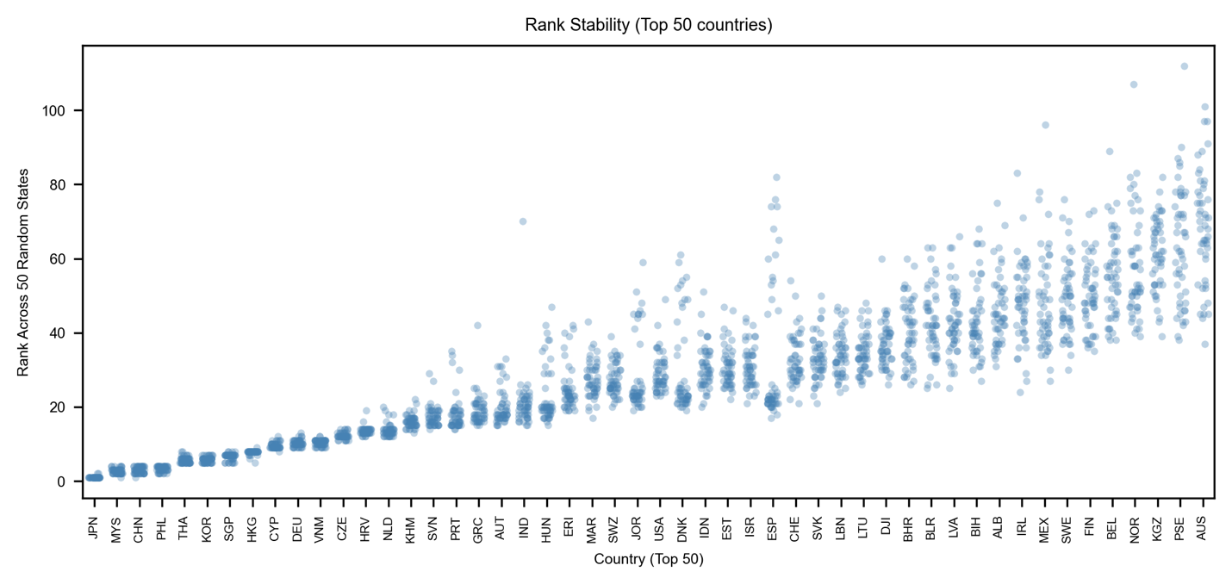
Figure SI. 32. Wind rankings summary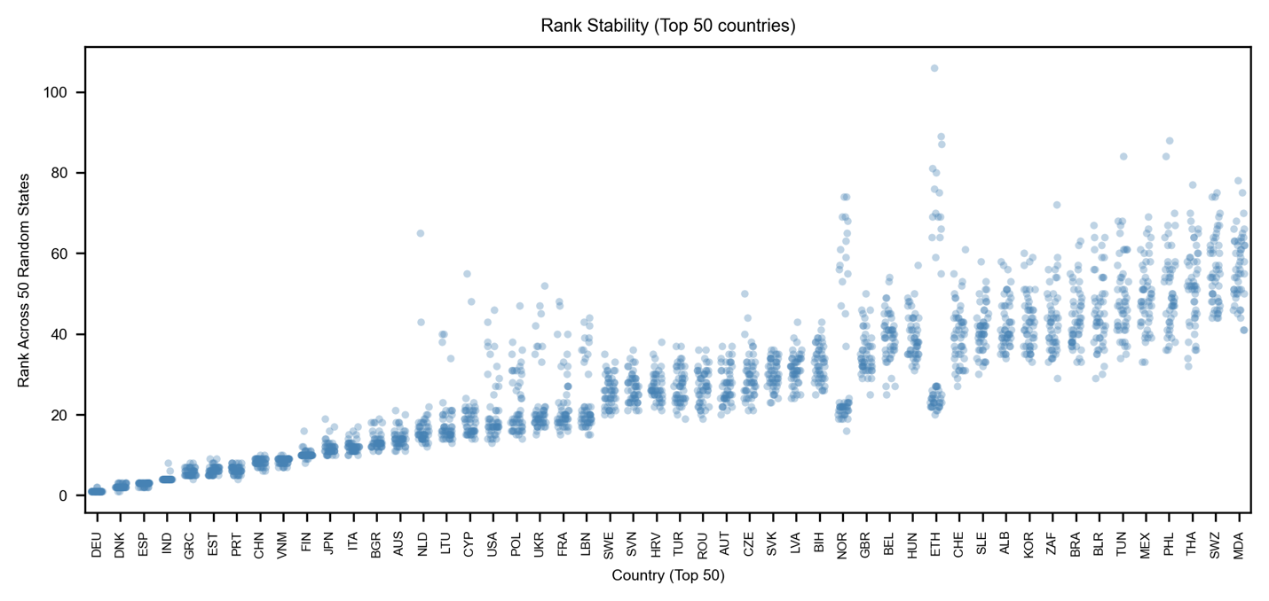

Figure SI. 33. Battery rankings summary
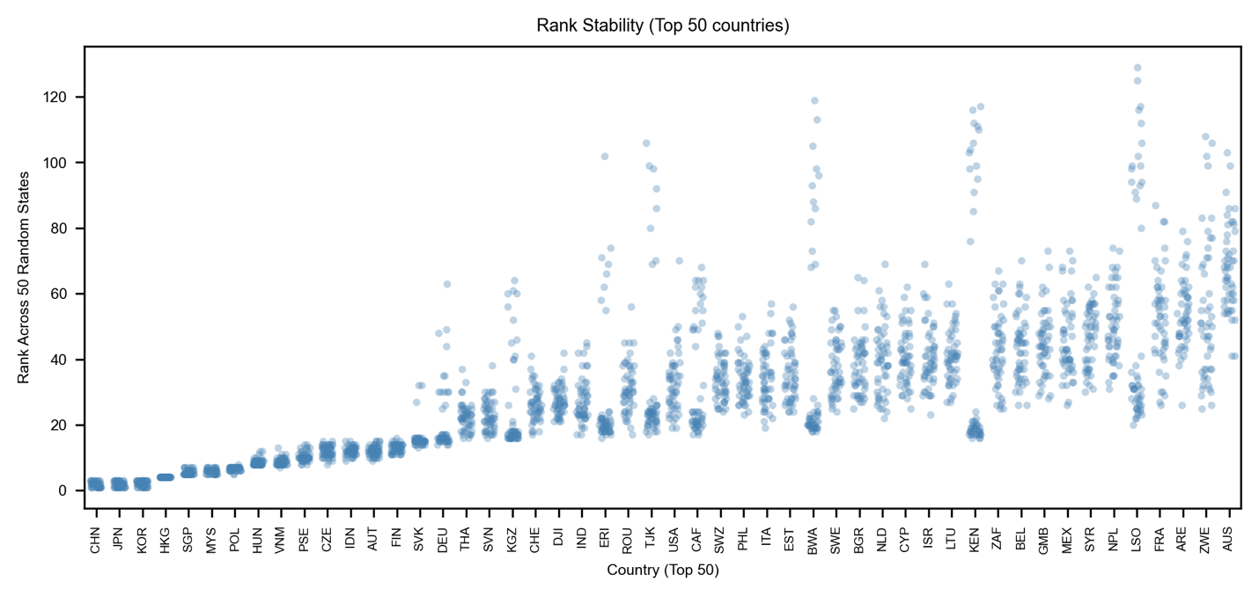
Figure SI. 34. Biofuel rankings summary
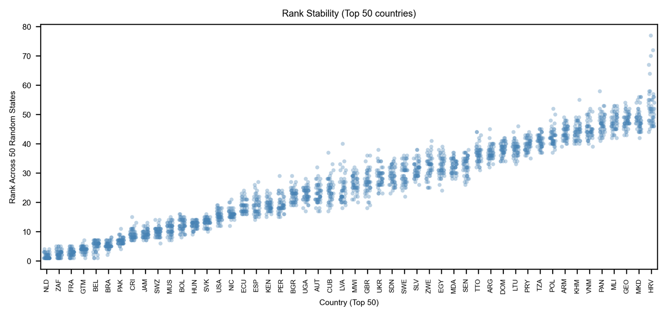
Figure SI. 35. Geothermal rankings summary
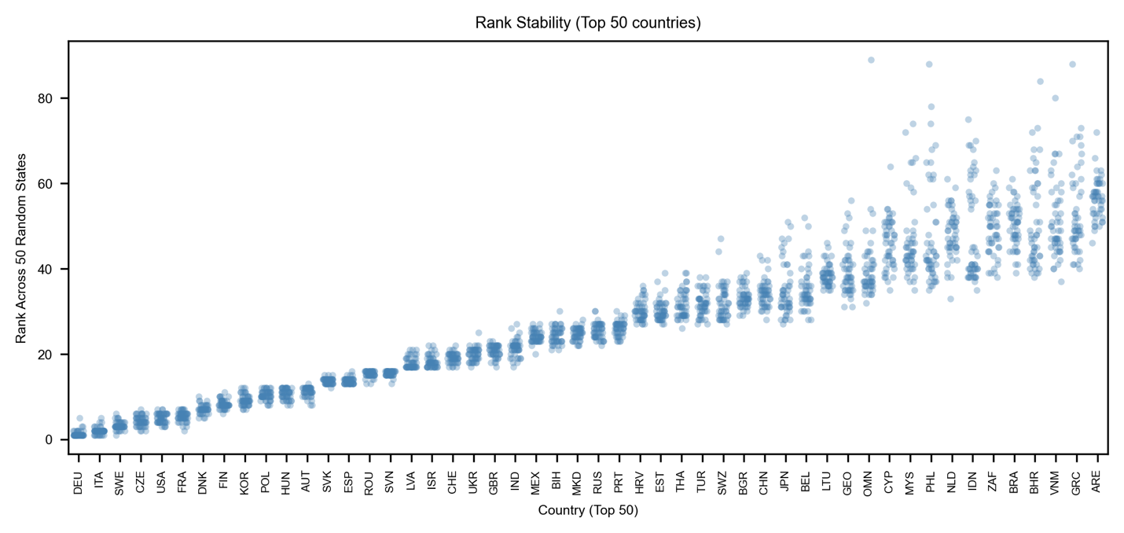

Figure SI. 36. Nuclear rankings summary
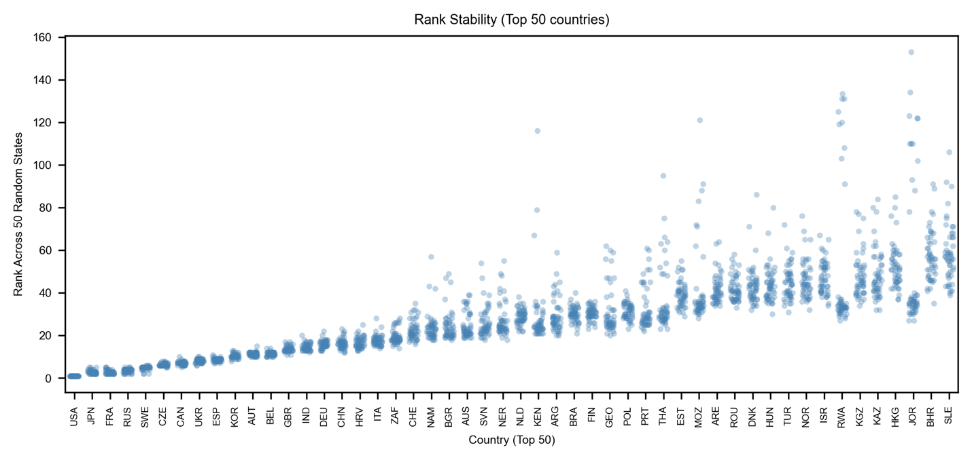
Figure SI. 37. Electrolyzers rankings summary
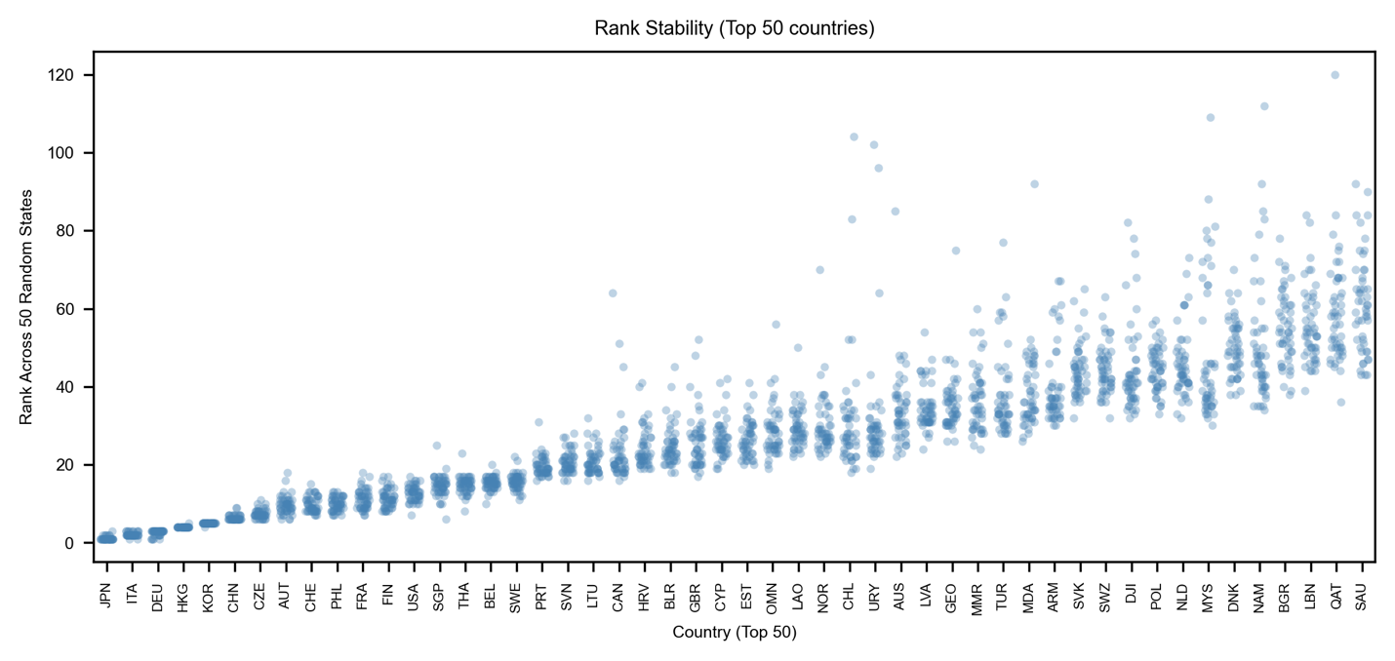
Figure SI. 38. Heat Pump rankings summary
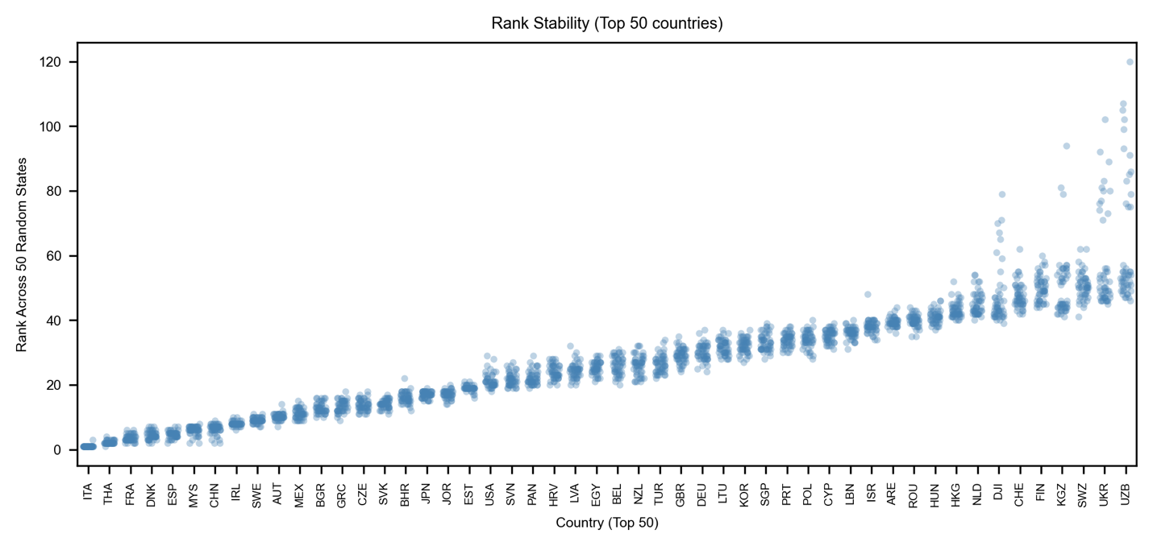
Figure SI. 39. Permanent magnets rankings summary
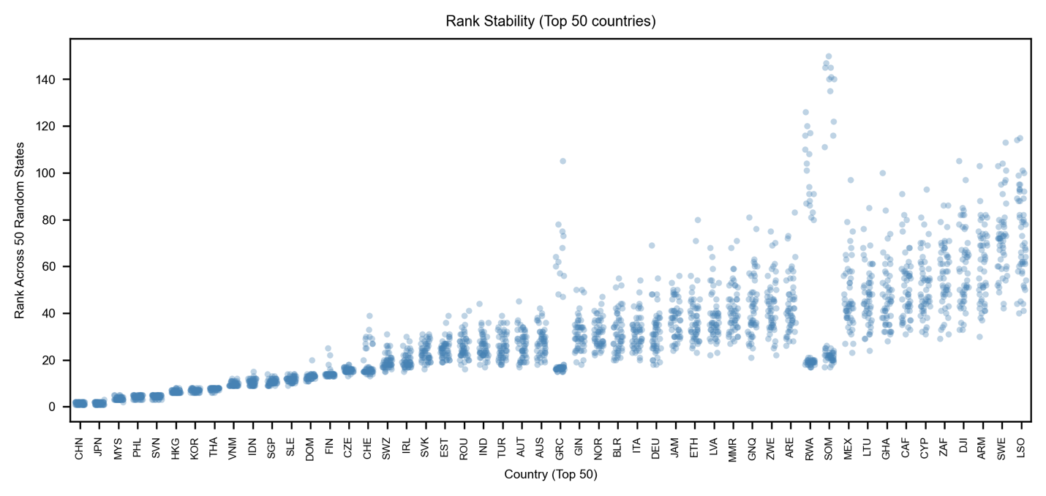
Figure SI. 40. Transmission rankings summary
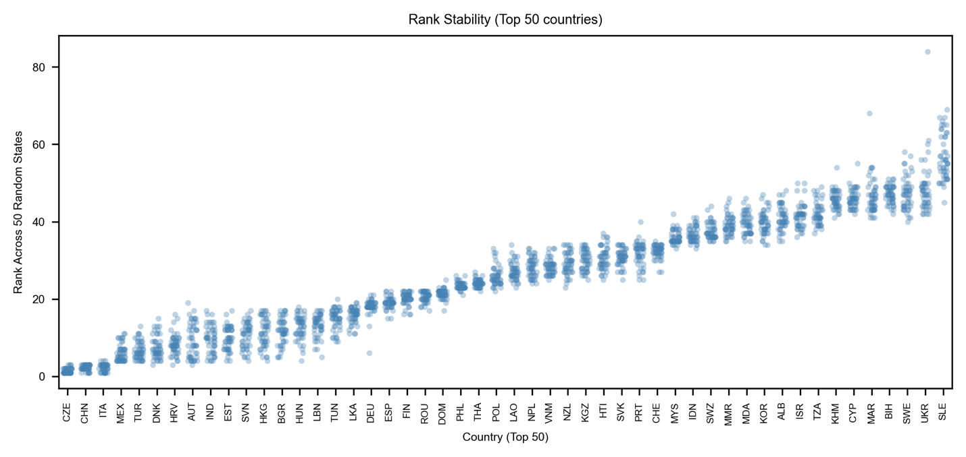
Figure SI. 41. Electrolyzer predicted competition
